COMPARATIVE ASSESSMENT OF INDOOR AIR QUALITY IN EBONYI STATE TERTIARY HEALTHCARE SYSTEM
(FETHA 2)

BY

EKPE DONALD AGBO
2020/EN/15057

A PROJECT RESEARCH SUBMITTED IN PARTIAL FULFILMENT OF THE REQUIREMENTS FOR THE AWARD OF BACHELORS OF ENGINEERING (B.ENG.) DEGREE IN CIVIL ENGINEERING

DEPARTMENT OF CIVIL ENGINEERING, FACULTY OF ENGINEERING AND TECHNOLOGY, ALEX EKWUEME FEDERAL UNIVERSITY, NDUFU-ALIKE, EBONYI STATE.

PROF. C. EZEAH

NOVEMBER 2025
CERTIFICATION
It is hereby certified that this research project titled COMPARATIVE ASSESSMENT OF INDOOR AIR QUALITY IN EBONYI STATE TERTIARY HEALTHCARE SYSTEM (FETHA 2), is an original work conducted, carried out and written by EKPE DONALD AGBO with (Registration Number) 2020/EN/15057 in partial fulfillment of the requirements for the award of Bachelor of Engineering (B.Eng.) degree in the Department of Civil Engineering, Faculty of Engineering, Alex Ekwueme Federal University, Ndufu Alike, Ebonyi state.

…………………… …………………..
Supervisor Date

…………………… …………………..
Head of Department Date

……………………… ……………………
External Supervisor Date

DEDICATION
This project is lovingly dedicated to my family, whose unwavering support, encouragement, and belief in my aspirations have been the cornerstone of my academic journey. Their love and sacrifices have inspired me to strive for excellence in this study on improving indoor air quality in healthcare facilities, a work aimed at enhancing the health and well-being of others.

ACKNOWLEDGEMENT
I am deeply grateful to God Almighty for His boundless mercy and grace, which have sustained me throughout my academic journey and made the completion of this project possible. His divine guidance has been my anchor in every challenge.
I express my heartfelt appreciation to my supervisor, Engr. Prof. Ezeah C for his invaluable guidance, insightful feedback, and constant encouragement and sincere appreciations to all staff in the department of Civil Engineering who carried out their duties tirelessly. Their expertise and dedication significantly shaped the direction and quality of this research on indoor air quality at the Alex Ekwueme Federal Teaching Hospital Abakaliki.
My profound gratitude goes to my mother and my father, Mr Olo Emmanuel Ekpe, whose financial support and sacrifices provided the foundation for my education and the resources necessary to undertake this project. His belief in me has been a source of strength and motivation.
To all who have contributed in various ways to the success of this work, I offer my sincere thanks. Your support has been instrumental in bringing this study to fruition.

TABLE OF CONTENTS
Title Page………………………………………………………………… i
Certification……………………………………………………………….. ii
Dedication…………………………………………………………………. iii
Acknowledgement………………………………………………………… iv
Table of contents………………………………………………………….. v
List of Tables………………………………………………………………. vi
List of Figures……………………………………………………………… ix
List of Symbols/Nomenclature…………………………………………….. xii
Abstract…………………………………………………………………….. xiv

CHAPTER ONE: INTRODUCTION
1.1 Background of the Study………………………………………………….. 1
1.2 Statement of the Problem…………………………………………………... 2
1.3 Objectives of the Study……………………………………………………… 2
1.4 Scope of the Research...................................................................................... 3
1.5 Significance of the Study…………………………………………………… 3
1.6 Justification of the Study……………………………………………………. 4
1.7 Study Limitations…………………………………………………………….. 5
CHAPTER TWO: LITERATURE REVIEW
2.1 Overview of Indoor Air Quality……………………………………………… 6
2.2 Hospital Air Quality Standards………………………………………………. 6
2.3 Factors Affecting Indoor Air Quality in Healthcare Settings……………….. 7
2.4 Health Implications of Poor IAQ………………………………………… 8
2.5 Review of Related Studies……………………………………………….. 9
CHAPTER THREE: RESEARCH METHODOLOGY
3.1 Introduction……………………………………………………………… 11
3.2 Study Area Description………………………………………………….. 11
3.3 Research Design………………………………………………………… 12
3.4 Data Collection Methods……………………………………………….. 13
3.5 Sampling Techniques…………………………………………………… 14
3.6 Analytical Procedures…………………………………………………… 15
3.7 Data Analysis……………………………………………………………. 16
3.8 Ethical Considerations…………………………………………………… 17
3.9 Limitations of the Study…………………………………………………. 17
CHAPTER FOUR: RESULTS AND DISCUSSION
4.1 Introduction................................................................................................. 18
4.2 Questionnaire Survey Results……………………………………………. 19
4.2.1 Demographic Characteristics……………………………………………. 19
4.2.2 Awareness and Ratings of IAQ…………………………………………. 20
4.2.3 Frequency of IAQ Monitoring and Maintenance………………………. 21
4.2.4 Severity of IAQ Issues…………………………………………………. 22
4.2.5 Facility Features and Training……………………………………………. 23
4.2.6 Urgency of IAQ Improvements……………………………………………. 24
4.3 IAQ Measurement Results……………………………………………... …. 24
4.3.1 Daily Pollutant Concentrations……………………………………………. 25
4.3.2 Average Concentrations………………………………………………….. 26
4.4 Discussion……………………………………………………………….. 27
4.4.1 Indoor/Outdoor (I/O) Ratios……………………………………………. 27
4.4.2 Comparison with WHO Standards……………………………………… 30
4.4.3 Comparison with Previous Studies………………………………………… 34
4.4.4 Correlation between Measurements and Questionnaire Perceptions………… 36
4.4.5 Effects and Applications of Results………………………………………… 36
4.5 Practical Effects and Applications……………………………………………. 36
4.6 Limitations and Notes on Interpretation……………………………………… 37
CHAPTER FIVE: CONCLUSION AND RECOMMENDATIONS
5.1 Conclusion……………………………………………………………………... 38
5.2 Recommendations……………………………………………………………… 39
A. Hospital Management Strategies……………………………………………….. 39
B. Recommendations for Policymakers and Regulators…………………………… 39
C. Directions for Future Research…………………………………………………. 40
Remark……………………………………………………………………………... 40
Reference List…………………………………………………………………….. 41

LIST OF TABLES
Chapter 3: Research Methodology
Table (3.1): Equipment and Materials
◦Section: 3.5 Sampling Techniques
◦Description: Details the parameters (CO, NO₂, H₂S, NH₃), equipment used (e.g., real-time monitor, passive samplers), and methods (e.g., sampled at breathing zone height, 7-day exposure).
Chapter 4: Results and Discussion
Table 4.1: Demographic Characteristics of Respondents
◦Section: 4.2.1 Demographic Characteristics
◦Description: Summarizes the age, role, and years of experience of the 27 questionnaire respondents.
Table 4.2: Mean Severity Ratings of IAQ Issues
◦Section: 4.2.4 Severity of IAQ Issues
◦Description: Lists mean severity ratings and standard deviations for IAQ issues (chemical odors, mold/mildew, smoke, stale air).
Table 4.3: Daily Concentrations of Gaseous Pollutants (ppm)
◦Section: 4.3.1 Daily Pollutant Concentrations
◦Description: Provides daily measurements of CO, NO₂, NH₃, and H₂S across female, male, emergency wards, outdoor areas, and the control site.
Table 4.4: Average Concentrations and Standard Deviations (ppm)
◦Section: 4.3.2 Average Concentrations
◦Description: Summarizes average concentrations and standard deviations of CO, NO₂, NH₃, and H₂S across locations.
LIST OF FIGURES
Chapter 4: Results and Discussion
Figure 1: Distribution of responses for ‘2. Age’
◦Section: 4.2.1 Demographic Characteristics
◦Description: Shows the distribution of respondents’ ages.
Figure 2: Distribution of responses for ‘Years of experience’
◦Section: 4.2.1 Demographic Characteristics
◦Description: Illustrates the distribution of respondents’ years of experience.
Figure 3, Chart 4.1: Bar Chart of Mean Ratings for Awareness, IAQ Quality, and Ventilation System
◦Section: 4.2.2 Awareness and Ratings of IAQ
◦Description: Displays average ratings with error bars for standard deviations, highlighting moderate awareness and perceptions of IAQ and ventilation.
Figure 4, Chart 4.2: Distribution of responses for ‘7. How often does your facility monitor IAQ?’
◦Section: 4.2.3 Frequency of IAQ Monitoring and Maintenance
◦Description: Shows the frequency of IAQ monitoring practices among respondents.
Figure 5, Chart 4.3: Rate the severity of the following IAQ issues in your facility
◦Section: 4.2.4 Severity of IAQ Issues
◦Description: Presents the severity ratings of IAQ issues such as chemical odors, mold/mildew, smoke, and stale air.
Figure 6, Chart 4.4: Bar Chart of Distribution of responses for ‘9. How frequently do you experience poor IAQ symptoms?’
◦Section: 4.2.4 Severity of IAQ Issues
◦Description: Indicates the frequency of poor IAQ symptoms experienced by respondents.
Figure 7, Chart 4.5: Distribution of responses for ‘12. Does your facility have the following? (Tick if yes)’
◦Section: 4.2.5 Facility Features and Training
◦Description: Shows the presence of facility features like windows, air purifiers, and reports of leaks or dampness.
Figure 8, Chart 4.6: Stacked Bar Chart of Urgency Rankings for IAQ Improvements
◦Section: 4.2.6 Urgency of IAQ Improvements
◦Description: Illustrates the urgency rankings for proposed IAQ improvements such as ventilation, maintenance, training, and IAQ monitors.
Figure 9, Chart 4.7: Bar Chart of Average Pollutant Concentrations by Location
◦Section: 4.3.2 Average Concentrations
◦Description: Illustrates average concentrations of pollutants across different locations, with the control site showing lower values.
Figure 10, Chart 4.8: Line Graph of Pollutant Concentrations Over Five Days (Average Across Indoor Locations)
◦Section: 4.3.2 Average Concentrations
◦Description: Shows temporal trends of NO₂ and H₂S concentrations, highlighting peaks on Day 2 and Day 4, respectively.
Figure 11, Chart 4.9: CO Indoor/Outdoor Ratio
◦Section: 4.4.1 Indoor/Outdoor (I/O) Ratios
◦Description: Displays the indoor/outdoor ratio for carbon monoxide (CO) across wards.
Figure 12, Chart 5.0: NO₂ Indoor/Outdoor Ratio
◦Section: 4.4.1 Indoor/Outdoor (I/O) Ratios
◦Description: Shows the indoor/outdoor ratio for nitrogen dioxide (NO₂), with elevated levels indoors.
Figure 13, Chart 5.1: NH₃ Indoor/Outdoor Ratio
◦Section: 4.4.1 Indoor/Outdoor (I/O) Ratios
◦Description: Illustrates the indoor/outdoor ratio for ammonia (NH₃), indicating indoor enrichment.
Figure 14, Chart 5.2: H₂S Indoor/Outdoor Ratio
◦Section: 4.4.1 Indoor/Outdoor (I/O) Ratios
◦Description: Highlights the indoor/outdoor ratio for hydrogen sulfide (H₂S), with a notable spike in the emergency ward.
Figure 15, Chart 5.3: Exceedance rate of CO
◦Section: 4.4.2 Comparison with WHO Standards
◦Description: Shows the exceedance rate of CO compared to WHO guidelines.
Figure 16, Chart 5.4: Exceedance rate of NO₂
◦Section: 4.4.2 Comparison with WHO Standards
◦Description: Illustrates the exceedance rate of NO₂, indicating levels above WHO guidelines.
Figure 17, Chart 5.5: Exceedance rate of H₂S
◦Section: 4.4.2 Comparison with WHO Standards
◦Description: Displays the exceedance rate of H₂S, highlighting the Day 4 spike in the emergency ward.
Figure 18, Chart 5.6: Daily distribution of CO across locations
◦Section: 4.4.2 Comparison with WHO Standards
◦Description: Represents the daily distribution of CO concentrations across locations for five days.
Figure 19, Chart 5.7: Daily distribution of NO₂ across locations
◦Section: 4.4.2 Comparison with WHO Standards
◦Description: Shows the daily distribution of NO₂ concentrations, with a peak on Day 2.
Figure 20, Chart 5.8: Daily distribution of NH₃ across locations
◦Section: 4.4.2 Comparison with WHO Standards
◦Description: Illustrates the daily distribution of NH₃ concentrations across locations.
Figure 21, Chart 5.9: Daily distribution of H₂S across locations
◦Section: 4.4.2 Comparison with WHO Standards
◦Description: Represents the daily distribution of H₂S concentrations, highlighting the Day 4 spike.

LIST OF SYMBOLS/NOMENCLATURE

SYMBOL/TERM | DESCRIPTION
IAQ | Indoor Air Quality: Refers to the condition of air within and around buildings, with emphasis on occupant health and comfort.
CO | Carbon Monoxide: A colorless, odorless gas measured in parts per million (ppm).
NO₂ | Nitrogen Dioxide: A gaseous pollutant measured in parts per million (ppm), associated with respiratory health risks.
NH₃ | Ammonia: A gaseous compound measured in parts per million (ppm), often linked to cleaning agents and waste management.
H₂S | Hydrogen Sulfide: A gaseous pollutant measured in parts per million (ppm), associated with odor and respiratory irritation.
PM2.5 | Particulate Matter (2.5 micrometers or smaller): Fine particles that can penetrate deep into the lungs, mentioned in objectives but not measured in results.
PM10 | Particulate Matter (10 micrometers or smaller): Larger particulate matter, mentioned in objectives but not measured in results.
VOCs | Volatile Organic Compounds: Organic chemicals that can affect air quality, mentioned in objectives and literature review.
CO₂ | Carbon Dioxide: A gas measured to assess ventilation adequacy, mentioned in objectives and methodology but not in results.
ppm | Parts Per Million: Unit of concentration used for gaseous pollutants (CO, NO₂, NH₃, H₂S).
μg/m³ | Micrograms per Cubic Meter: Unit of concentration used for NO₂ in WHO guidelines (e.g., 200 μg/m³ equivalent to 0.106 ppm for 1-hour exposure).
I/O Ratio | Indoor/Outdoor Ratio: Ratio comparing indoor pollutant concentrations to outdoor concentrations, used to assess indoor contributions.
WHO | World Health Organization: Provides air quality guidelines used as benchmarks (e.g., CO: 9 ppm for 8 hours; NO₂: 0.106 ppm for 1 hour).
ASHRAE | American Society of Heating, Refrigerating, and Air-Conditioning Engineers: Provides standards for ventilation and IAQ.
NIOSH | National Institute for Occupational Safety and Health: Provides guidelines for occupational exposure limits (e.g., NH₃: 25 ppm 8-hour TWA).
CFU | Colony-Forming Units: Measure of microbial load in air samples, used in methodology for assessing bacterial and fungal contamination.
TWA | Time-Weighted Average: Used in occupational exposure limits (e.g., NH₃ NIOSH REL of 25 ppm).
STEL | Short-Term Exposure Limit: Used for NH₃ (e.g., NIOSH STEL of 35 ppm).
HEPA | High-Efficiency Particulate Air: A Type of filtration recommended for improving IAQ.
PID | Photoionization Detector: An Instrument used to measure VOCs in the methodology.
GC-MS | Gas Chromatography-Mass Spectrometry: Method used for NO₂ analysis with passive samplers.
ANOVA | Analysis of Variance: A Statistical method used to assess variations in IAQ across hospital sections.
SD | Standard Deviation: A Statistical measure used to describe variability in pollutant concentrations and survey responses.

ABSTRACT
Indoor air quality (IAQ) in healthcare facilities is critical for patient safety, staff well-being, and infection control, yet empirical data in Nigerian tertiary hospitals remains limited. This study evaluated IAQ at the Alex Ekwueme Federal Teaching Hospital, Abakaliki (AEFTHA), Ebonyi State, Nigeria, focusing on gaseous pollutants across the female surgical ward, male surgical ward, emergency ward, hospital outdoor areas, and a control site at Ebonyi State University Farm.
Employing a mixed-methods approach, air quality parameters—carbon monoxide (CO), nitrogen dioxide (NO₂), ammonia (NH₃), and hydrogen sulfide (H₂S)—were measured over five days (8:00 AM to 4:00 PM) using calibrated sensors at breathing zone height. A questionnaire survey assessed perceptions among 27 healthcare staff. Data were analyzed using descriptive statistics, indoor/outdoor ratios, and comparisons to World Health Organization (WHO) guidelines.
Results indicated CO levels (0.69–0.89 ppm) were consistently low and below WHO 8-hour limits (9 ppm). However, NO₂ concentrations (average 0.38–0.44 ppm) exceeded the WHO 1-hour guideline (0.106 ppm) by 3–4 times, particularly in the female surgical ward, likely due to generator emissions and traffic infiltration. NH₃ levels (0.11–0.33 ppm) showed indoor enrichment from cleaning agents, while H₂S exhibited a spike (0.19 ppm) in the emergency ward on Day 4, surpassing the WHO 24-hour limit (0.1 ppm). Control site readings were markedly lower (e.g., NO₂ at 0.02 ppm), highlighting hospital-specific sources. Staff reported moderate IAQ awareness (mean 3.22/5), perceived chemical odors as the most severe issue (3.41/5), and prioritized ventilation improvements and training.
Findings underscore elevated respiratory risks from NO₂ and H₂S, emphasizing infrastructural deficiencies in Nigerian hospitals. Recommendations include enhanced ventilation systems, routine IAQ monitoring, staff education, and policy alignment with WHO standards to mitigate hospital-acquired infections and improve health outcomes. Future research should incorporate seasonal variations and additional pollutants for comprehensive IAQ management.
CHAPTER ONE
INTRODUCTION
1.1 Background of the Study
The IAQ of healthcare facilities has been focused on more for its important effects related to patient safety, the health of medical staff, as well as overall healthcare gains. As closed places with dense populations, hospitals are prone to indoor air contaminants such as particulates, volatile organic compounds (VOCs), microbial agents, and gaseous pollutants. These pollutants originate from medical procedures, cleaning practices, and external sources, whose presence may threaten the health of patients (particularly those who are already ill or weak) as well as hospital personnel.
The Alex Ekwueme Federal Teaching Hospital Abakaliki (AEFTHA) is one of the major tertiary institutions in Ebonyi State, Nigeria. Between the liveliness of city streets, a platform echoes with din and blends into a raucous symphony. Momentary ray ships of towering apartments for starring red light in the night sky, those palaces below start getting their futuristic garb too. Looking at the flow of these people between buildings, every single one is a lone ranger amidst so much activity. Smells of cooking food and engine exhaust ha still create an intoxicating brew of aromas in your nostrils. Having lived through so busy and confused an existence, there can be nothing but vitality coursing through the city--just a sheer pulse driving at music speed out every other message.
Notwithstanding the pivotal nature of IAQ in health care facilities, there is a paucity of data on what obtains with regard to IAQ in Nigerian tertiary hospitals, including those situated within Ebonyi State. This investigation is therefore designed to assess the IAQ in different departments of AEFTHA using both chemical and microbiological parameters, with a view to providing a baseline that can be used to make recommendations for improving environmental health status within the hospital.
1.2 Statement of the Problem Most Nigerian hospitals do not consider the effect of IAQ. It's a domain of wellness that is frequently discarded, but one that has an enormous bearing on how fast patients recover. Air quality is poor in many hospitals with no ventilation systems or monitoring. Indoor Air Quality is a concept under-researched but with considerable safety implications in these institutions. The decline in sensitivity had the consequence of a blind spot in the medical personnel. There is therefore the necessity for further research and data-based studies to investigate this area, as well as educate the people of Ebonyi state on the effect of Indoor Air quality. This research tries to address the intellectual vacuum due to the lack of empirical work.
Tertiary health centers like AEFTHA have an enormous task in meeting the standards set for indoor air quality (IAQ) due to ever-increasing patient load, poor environmental surveillance, and enforcement of policies. The lack of IAQ monitoring programs in hospitals delays the building of baseline data required for focused interventions. Due to health consequences and possible airborne transmission of infections within hospital settings, the goal of this study is to monitor and assess indoor air quality in AEFTHA for environmental safety and health upgrading.
1.3 Objectives of the Study The objective is to carry out a critical assessment of Indoor Air Quality (IAQ) at Alex Ekwueme Federal Teaching Hospital in Abakaliki, Ebonyi State, with a multidisciplinary approach.
Specific Objectives 1. Quantify and evaluate concentrations of particulate matter (PM2.5 and PM10), carbon monoxide (CO), carbon dioxide (CO₂), and volatile organic compounds (VOCs), as well as biological agents including airborne bacteria, fungi, viruses, and other pathogenic organisms in various hospital departments. (Deconstructing data into parts to look for patterns.)
2. Compare the measured IAQ factors to the World Health Organization (WHO) levels and national indoor air quality guidelines for compliance.
(Evaluating information based on prior knowledge or personal perspective.)
3. Assess the health risks associated with compromised IAQ to healthcare workers and patients by correlating pollutant concentrations with reported complaints related to health. (Making judgments based on evidence.)
4. Develop evidence-based guidelines for the facility to manage IAQ, which are practical and cost-effective, aiming at sustainability in intervention. (Designing campaigns to remediate identified problems.)
1.4 Scope of the Research
This study was developed to compare the indoor air quality (IAQ) of different healthcare facilities in Abakaliki, Ebonyi State. It will, in particular, assess tertiary, secondary, primary, and private hospitals. The investigation will involve the monitoring of representative air quality elements such as particulate matter, CO2, carbon monoxide (CO), humidity, and microbial pollutants. Also, for the data collection, the study will use air quality measuring devices and questionnaire surveys. Through analyzing data, this research will focus on investigating the variation in IAQ among different healthcare facilities and its impact on public health. The results will guide policymakers and health professionals to take suitable actions to control indoor air pollution.
In general, there is an aim of providing useful information that will assist in establishing the relationship between IAQ and health impacts in Ebonyi State with respect to aspects of healthcare.
1.5 Significance of the Study It's an important study in a few ways. It will also provide vital data on indoor air quality in health facilities in Ebonyi State. And it would advance good, strong environmental health policies around the country. It would reduce the health risks for its staff, it would help patients recover and be discharged more quickly, and it would help hospital/ care home managers pragmatically manage the IAQ. Students, lecturers, and the stakeholders in the AE-FUNAI Civil Engineering department would also be potential beneficiaries of this study. This would have been a future study since there is very little current literature in this area, and to have a model for health-related Air quality to drive health care environment research.
This study seeks to reveal important aspects about IAQ in healthcare facilities in Ebonyi state, which will be useful in a number of ways:
1. Patient Safety and Healthcare Outcomes: A better IAQ can lower HAIs as well as the frequency of Hospital-Acquired Infections and improve overall health outcomes by pinpointing specific air quality problems that negatively impact the health of patients.
2. Staff Productivity and Health: The study emphasizes how IAQ may affect the well-being of healthcare staff, ultimately affecting morale and efficiency.
3. Policy Implication: Information will help policy makers and health care managers to take well-informed decisions in the management of IAQ, and plan intervention activities according to need.
4. Community Awareness and Training: Through the exposure of inequities in IAQ, the study will increase community awareness regarding how important air itself is within the work of healthcare and teach the demand for better requirements.
5. Relevance for further research: This work will bridge the gaps in IAQ studies in Nigeria and serve as a reference point for subsequent environmental factors influencing health infrastructure.
The study, in general, promotes better healthcare spaces that prioritize the wellness and safety of patients and workers.
1.6 Justification of the Study
Patients and healthcare workers are fundamental to providing effective healthcare delivery. The AEFTHA is a big hospital in Ebonyi State and needs to have an environment that is clean and safe. The result of this research will bridge existing gaps in knowledge and serve as an advocacy tool for policy makers, hospital managers, and environmental health workers in Nigeria. Through pinpointing the pollutants and sources, it will help design better management strategies for IAQ and infection control; it will also change clinical behaviors among staff to meet the international standard for environmental safety in hospitals.

1.7 Study Limitations
This study has some limitations that may affect the results: 1. Geographic Focus: The survey was limited to healthcare facilities in Abakaliki, Ebonyi State, and the results may not be generalizable beyond the study area.
2. Limitations of the study are that data were only collected over a relatively short period and might not account for seasonal variation in air quality.
3. Sample size: The sample of healthcare facilities covered in the study may not be big enough to get a comprehensive representation of the indoor air quality in China.
4. Equipment: Problems with the devices used for air quality monitoring would affect the validity of information provided.
5. Environmental Factors: The study may be failing to control for other factors, such as construction, vehicle emissions, or environmental events that could influence air quality.
6. Human Error: Errors in sampling and analysis can introduce errors into the results, even though all available precautions are taken.
7. Subjectivity in Surveys: Survey responses may be biased based on personal opinions and experiences.
8. Focus on Selected Parameters: The study emphasizes specific air quality indicators, but other harmful factors may also be significant.
These limitations should be taken into consideration when interpreting the results, and they indicate directions for future research regarding IAQ in healthcare.

CHAPTER TWO
LITERATURE REVIE
2.1 Overview of indoor air quality
Indoor air quality (IAQ) is said to be the condition of air inside and outside buildings, with particular emphasis on the health and wellbeing of their occupants. It is very critical especially in healthcare environments, like hospitals, where vulnerable patients, healthcare workers, and visitors, are sharing the same indoor environment. And that air, if it deteriorates, can quietly harm everyone. Sundell et al. (2011).
Lately, Ackley et al. (2024) remind us: checking the air isn’t enough. You might also want to notice how warm the room feels, how loud the hallway echoes, or whether the lights strain tired eyes. All these little things weave together. All these interconnected elements put together can influence overall health outcomes and well-being of everyone in the healthcare facility.
2.2 Hospital air quality standards
Hospitals are not permitted to operate without strict adherence to established indoor air quality (IAQ) standards and guidelines. As a result, hospitals are strictly mandated to adhere to indoor air quality (IAQ) standards and Guidelines from heavy hitters like the World Health Organization (WHO, 2021) and the American Society of Heating, Refrigerating, and Air-Conditioning Engineers (ASHRAE). WHO’s global air quality guidelines have outlined acceptable limits for a range of airborne pollutants, which includes particulate matter (PM2.5 and PM10), carbon monoxide (CO), carbon dioxide (CO₂), volatile organic compounds (VOCs), and biological contaminants like bacteria and viruses.
In Italy, people there talk about air and how important it is to manage it: every detail counts. They do not worry only about germs (those invisible hospital souvenirs) but also about chemical whiffs from cleaners or machines. Settimo et al. (2020) drew our attention to an increasing acknowledgment of the significance of IAQ in hospital settings within Italy. Although widely cited, this evolving perspective signifies a more integrated approach to managing air quality while addressing not only microbial contamination that is vital for preventing healthcare-associated infections but also addressing the presence of chemical pollutants. It is therefore essential to provide efficient ventilation systems in order to maintain air quality, ensuring proper circulation of fresh air and the effective removal of pollutants. When it hums right, fresh air slips in, stale air slips out, and everyone breathes a little easier.
2.3 Factors affecting indoor air quality in healthcare settings
Indoor air quality (IAQ) within healthcare facilities, particularly hospitals, is affected by various interrelated factors that can considerably compromise the health and safety of patients, staff, and visitors. The primary contributors to inadequate IAQ include the following:
1. Inadequate Ventilation: Outdated ventilation systems that do not provide adequate fresh air circulation is a common challenge that numerous hospitals may face. Old ventilation systems that wheeze instead of breathe. Little ventilation gives room for airborne contaminants from prior activities to persist. Such inadequacy may lead to the accumulation of airborne pollutants and pathogens, posing great risks in clinical environments having vulnerable populations.
2. Overcrowding: A large number of patients in hospital wards can worsen the concerns regarding indoor air quality by bringing bacteria and viruses among others, and consequently letting their concentration rise. Overcrowding often leads to increased HVAC (heating, ventilation, and air conditioning) system stress, which subsequently decreases air quality.
3. Chemical Emissions: Using different kinds of cleaning agents and disinfectants which plays a major role in infection control, can be a source of VOCs (volatile organic compounds) and other toxic chemicals in the atmosphere. Long-term exposure to such substances may cause irritations in the respiratory system and so, both the patients and healthcare workers can suffer from the health problems associated with the irritations.
4. Medical Equipment Emissions: The use of different kinds of medical equipment, like diagnostic machines and steam sterilizers, may lead to ozone and particulate matter being released which, in turn, exacerbates the already existing problem of poor indoor air quality. The air pollution created by such devices can be more severe in closed areas if proper ventilation is not provided.
5. Pathogen Influx: Bringing in and out patients and visitors may result in the introduction of airborne pathogens over a large area since hospitals are hotspots for many contagious diseases. Changing of patients and doctors to such an extent will only be a factor to the already existing cross-contamination problem.
6. Seasonal Variations: Indoor air quality levels have been shown to vary a lot with the change in season according to studies. For instance, the research by Chamseddine et al. (2019) pointed out that the fluctuations in temperature and humidity directly affect the ventilation efficiency and hence, there are phases of poor air quality during extreme weathers.
7. Regulatory Challenges: The absence of strong policies regulating IAQ has led to less than optimal infection control measures in Ethiopian hospitals, as noted by Gizaw et al. (2016). This lack of regulation hampers the establishment of good practices that are required to effectively monitor and improve air quality in hospitals.
Knowing these aspects is vital for the plan’s more precise and focused actions towards IAQ improvement in hospitals, thus increasing patient safety and better healthcare outcomes all in all.
2.4 Health implications of poor IAQ
Poor indoor air quality (IAQ) in healthcare facilities greatly endangers the health of patients and staff. Central to this argument is the notion that poor IAQ may give rise to a wide range of health problems, which ranges from mild symptoms like headaches, fatigue, and dizziness to more serious conditions like chronic respiratory diseases, asthma exacerbations, and nosocomial infections, which are acquired during stays in hospitals. Yazdani et al. (2022).
Nabatanzi et al. (2021) carried out a detailed research which provided strong evidence that poor air quality is one of the most important factors causing respiratory diseases among medical staff and patients in the Uganda hospitals. The research found a direct relation between high levels of air pollutants and respiratory problems of the patients and pointed out the necessity of better air conditioning and filtration systems in hospitals as an urgent matter. Also, it should be mentioned that during the research period, the contamination of the air with microorganisms was still a serious problem in hospitals.
Addo et al. (2022) assessed bacterial and fungal contamination of the Ghanaian hospitals and reported that their findings were shocking as the contamination rates were higher than the maximum levels recommended for safety. The authors called for regular environmental monitoring and strict infection control measures as ways to reduce the health risks that might arise from the exposure to microorganisms.
Another study conducted by Oladele et al. (2014) drew attention to the fact that fungal diseases in Nigerian hospitals were made worse by the very humid and hot weather, which in turn, led to poor IAQ, and increased the likelihood of allergic reactions and even infections among the already weak patients. Thus, this call for the provision of good indoor environmental conditions in medical facilities in order to improve patients and healthcare provider’s safety.
2.5 Review of related studies
Various research studies have been done around the world and also specifically in Nigeria to look into the indoor air quality (IAQ) in hospitals. To give an example, a large-scale study done by Agwaranze et al. (2020) shedding light on the microbial IAQ in Nigerian hospitals has found very worrying amounts of bacteria and fungi in the air. The issue of contamination was especially severe in the wards that had a lot of patients coming in and out, as the air quality might get so bad that there would be a significant increase in the hospital infection rate.
More research conducted by Ejeh and colleagues in 2021 in the northern part of Nigeria disclosed that the fine particulate matter (PM2.5) levels in critical hospital areas were very alarming. The ICUs and outpatient clinics were the areas where the PM2.5 levels were highest. The presence of high PM2.5 levels is a major health concern as respiratory problems and other health issues may arise from long-term exposure. Also, Gizaw's group noted in 2016 that Ethiopian hospitals have been facing similar IAQ problems as those in Africa due to poor ventilation and little control by the government. In an international context, Asadi et al. (2020) looked into the aerosol transmission mechanism behind hospital-acquired infections and urged the need for modern air filtration systems in hospitals to largely eliminate these precautions.
In Ghana, Osei et al. (2023), through their research, have unambiguously demonstrated that hospitals lacking proper heating, ventilation, and air conditioning (HVAC) systems, have the carbon dioxide (CO2) concentration levels, during peak hours of operation, beyond 1000 ppm. Such levels indicate that there is not enough fresh air coming in and this is the biggest problem to be dealt with when it comes to ensuring that the indoor environment is safe for the occupants. Furthermore, Abubakar (2017) pointed out that the lack of adequate facilities in the Nigerian medical centers has been one of the foremost reasons for poor air quality.
This case emphasizes the immediate requirement for improved air quality management systems in the region. The studies if taken collectively point out the continuous demand for indoor air quality monitoring in hospitals, and opening up the way for proper policies to be well-established for the air quality of patients, medical staff, and visitors to be the safest. The whole process is called preventive and is of utmost importance to help reduce the risk of infections and to keep the hospitals in the condition of promoting healing through their environment.

CHAPTER THREE
RESEARCH METHODOLOGY
3.1 Introduction
This chapter provides comprehensive information on the materials and procedures employed to evaluate indoor air quality (IAQ) at the Alex Ekwueme Federal Teaching Hospital, Abakaliki (AEFTHA2). It starts with an extended overview of the study area, focusing on important aspects related to hospital design, ventilation systems, and environmental factors that might affect IAQ. The methodology specifies whether the research was cross-sectional, longitudinal, or experimental to understand changes in air quality over time. Furthermore, this section presents the data collection techniques applied, blending the two methodologies of quantitative and qualitative methods. Examples include physical measurements of airborne particles (particulate matter [PM]), volatile organic compounds, and surveys to determine how perceptions of air quality by staff and patients may relate to their health effects. The section on sampling techniques specifies the criteria for choosing sampling sites within the hospital, such as patient wards, ensuring a thorough representation of IAQ.
Finally, the chapter describes the analytical methods used (the statistical methods and software tools that were used to analyze the collected data). It also highlights the importance of durability and reliability, in turn furthering the amount of A E F T H A 2 (100) work, as it goes back to our main goal for this study: alert possible poor AQE problems and offer some solutions against health-related issues faced by patients & staff at AEFTHA2.
3.2 Study Area Description
Background (Local Setting and Policy Frameworks) The Federal Teaching Hospital Abakaliki II, otherwise referred to as FETHA II, is one of the tertiary medical institutions in Abakaliki city, Nigeria. This is an academic medical center and they are also training the next generation of health care professionals at the same time they are providing critical medical services to communities and regions in need.
FETHA II is focused on the advancement of medical education in teaching/preclinical, and research. It has various departments to treat many kinds of illnesses, so that the hospital could possibly become a total destination. Its close partnership with schools gives aspiring healthcare workers the freedom to learn. The focus of research at FETHA II is on widely prevalent diseases, particularly hypertension, TB, and other communicable/ noncommunicable diseases in Nigeria. The hospital is also home to a diverse range of academic publications that help advance public health knowledge and discoveries. Apart from clinical service and training, FETHA II works with bodies like the Wellcome Trust to improve health through research and health care services. The hospital maintains an international reputation for all-round excellence in health care delivery, research, and training, and a workplace free of discrimination. (Agwaranze et al., 2020).
3.3 Research Design
This comparison allows us to evaluate the degree to which the hospital’s air is different from the baseline air in rural situations that has been measured elsewhere. For the study, the Emergency Ward, Male Surgical Ward, and Female Surgical Ward at FETHA II, which are particularly known for having high patient occupancy and limited ventilation conditions, were selected for enrolment. The outdoor reference samples collected at the EBSU farm constitute a representation of clean and unpolluted air that will essentially serve as our point of comparison (Agwaranze et al., 2020).
A mixed method of data collection was used to give a comprehensive analysis. From the quantitative viewpoint, sophisticated measurement devices were employed to assess main air quality parameters in indoor environments (e.g., particulate matter, carbon dioxide concentration, and relative humidity). Qualitative data were collected simultaneously, through structured interviews and questionnaires of health workers and patients. These questionnaires were centered on their opinions and personal experiences about the air quality in the hospital environment. Through this hybrid approach, the study aims to conduct a holistic assessment of the IAQ status at FETHA II. It provides an indication of factors that might need changing and knowledge to support implementation strategies designed to improve the overall health and safety in hospital contexts for all concerned parties.

3.4 Data Collection Methods
The research used a strong and rich methodology that combines primary data collection in synergy with secondary sources for the purpose of adding to the rigor and richness of findings. Sampling was between 8:00 AM and 4:00 PM every day for five days in order to detect the diurnal changes (Emuren & Ordinioha, 2016).
Data Sources Raw data comprised both active and passive sampling. Additional data consisted of hospital maps and WHO/NIOSH standards for IAQ (World Health Organization [WHO], 2021; NIOSH, 2022).
Primary Data: A comprehensive survey of indoor air quality parameters in a healthcare facility has been measured and elaborated for assessing the indoor atmospheric condition level of IAQ. The methodology’s robustness in data collection comprises several parameters, including particulate matter, volatile organic compounds (VOCs), humidity levels, and temperature, which play a crucial role in the granular understanding of IAQ in these specific environments.
NO₂ (Dioxide of Nitrogen): The concentration of fine particulate matter, which can penetrate into the lungs and may cause long-term health issues, was measured using precision handheld particle counters.
Carbon Dioxide (CO₂): The concentration of CO₂ was measured using a commercial breathable CO₂ sensor, as elevated concentrations could indicate inadequate ventilation, and hospital staff and patients may feel uncomfortable or experience cognitive decline. The concentration of carbon monoxide, a colorless and odorless gas that can be dangerous even in small concentrations, especially in places with combustion sources, was measured using gas analyzers.
NH₃ (Ammonia): Specialized air-quality monitors were employed to identify a variety of VOCs, such as building materials, cleaning agents, and medical supplies that can negatively impact patient health and comfort.
H₂S (Hydrogen Sulfide): sampling of air by a method such as impaction or filtration allows the measurement of microbial loads (bacteria and fungi) that can lead to nosocomial infections.
Secondary Data: Secondary variables consisted of building plans and WHO/NIOSH systematic documents for IAQ (World Health Organization [WHO], 2021; NIOSH, 2022). Findings from the primary data were reinforced through a comprehensive review of extant records and literature. This included: Hospital IAQ Policies: Review of recommendations and protocols made by individual hospitals to learn about current practices in relation to regulatory mandates. WHO and ASHRAE Guidelines: In order to add context to our findings, these were compared with internationally accepted guideline levels for indoor air quality as defined by WHO and ASHRAE standards. Previous IAQ Assessments in Nigerian Hospitals: A Literature review of the literature on previous assessments conducted in Nigerian Hospitals will help to reveal trends and highlight knowledge gaps and best practices to control IAQ at local scenarios.
This two-pronged approach to data collection is intended to foster a holistic environment for the study of air quality in hospitals and inform strategies for improving patient safety and operational performance.
3.5 Sampling Techniques
There was stratified random sampling to ensure adequate representation from a diversity of hospital departments. The hospital was defined in different critical sub-sections to be able to reflect the complexity of patient care and operations. These sections include:
Emergency Ward: An area for the handling of immediate care, this can be seen as a front line to urgent cases and is likely to be a very high-pressure environment that would impact air quality. Male Surgical Ward: This is a special inpatient ward where male patients who have had an operation or are waiting for it are admitted, treated, and observed. It offers before and after surgery care, wound care, pain management, vital signs monitoring, and rehabilitation. Female Surgical Ward: This is a special unit of the hospital in which female patients are admitted, treated, and observed after being subjected to surgical operations or after surgery is performed. Like the male ward, it offers pre-operative and post-operative care to patients; however, it's a dedicated facility solely for female patients in order to maintain privacy, dignity, and gender-oriented care. Outdoor Areas (Outside the Wards): These are the hospital locations outside of buildings, and where patient tracking and standing activity may impact air quality measures. EBSU Farm (Control): Serving as a control site, the EBSU farm provides a contrasting environment for comparative analysis, facilitating the evaluation of environmental impacts away from the hospital’s direct patient care areas.
Sampling sites were randomly chosen from these areas, and a complete air quality assessment was conducted during 5days. Timing in this manner takes into consideration the variability of air quality around hospital daily rhythms, and makes relying on stringent data more sound.
Table 3.1: EQUIPMENT AND MATERIALS
PARAMETER | EQUIPMENT | METHOD
CO | Real-time monitor | Sampled at breathing zone height (1.2 meters above the ground)
NO₂ | Passive Samplers + GC‑MS | 7-day exposure and lab analysis
H₂S | Electrochemical sensors: | Often used in continuous air quality monitors or handheld detectors.
NH₃ | Hand-held or stationary IAQ monitors. | Air is drawn through a liquid or solid medium that captures NH₃.

All instruments were calibrated and operated based on ISO 17025 standards (NIOSH, 2022)
3.6 Analytical Procedures
The subsequent advanced instruments and methods were utilized to analyze air quality in fullness: H₂S: A top-of-the-range portable air quality monitor with an advanced laser particle counter. This piece of equipment allows for the precise reading of fine particulate matter concentration, giving an indication as to what one is taking into their body and/or releasing into the environment.
Carbon Monoxide (CO): These vital gases were measured with a highly sensitive gas monitor utilizing state-of-the-art electrochemical sensor technologies. This approach ensures exact measurements of CO₂ and CO concentrations, which are necessary for assessing overall air quality.
NH₃: For the total VOC concentration in the air, a photoionization detector (PID) was used. The instrument was developed as a rapid and on-site tool for the accurate determination of a large number of organic compounds, allowing for a wider knowledge of indoor and outdoor air quality.
NO₂: Air samples were selectively collected onto nutrient agar plates using a device equipped with an appropriate pump to evaluate the level of microbial contamination. After collection, the samples were incubated for 24 to 48 h. After incubation, colony-forming units (CFU) were calculated for the determination of microbiological load, providing information about potential biological hazards in the air.
This methodology provides a well-engineered, systematic approach for evaluating and controlling air quality that guarantees both the quality of the assessment and accuracy.
3.7 Data Analysis
Quantitative data of air quality measurements were analyzed by descriptive statistics containing means, standard deviations, and percentages. Analysis was performed against the air quality guidelines set forth by the WHO and ASHRAE to assess compliance. In addition, inferential statistical techniques (ANOVA and correlation test) were applied to compare indoor air quality (IAQ) between various parts of the hospital. Qualitative data obtained from the policy reviews were subject to thematic analysis
3.8 Ethical Considerations
The hospital ethics committee approved the study prior to initiation. Otherwise permission was obtained for monitoring from hospital executives to ensure appropriate supervision. Confidentiality was strictly adhered to at all stages of the study. The description of the statistical (mean, SD) have been used. Recommendations of the WHO and NIOSH were taken as reference. T or Wilcoxon tests were applied to compare indoor versus outdoor/ morning verse evening results. Correlation was carried out to investigate the relationship between ventilation rate, CO₂ level, PM and microbial load (Eghomwanre et al., 2022; Ibadin et al., 2025; NIOSH, 2022).
3.9 Limitations of the Study
This mixed-method approach aligns with similar IAQ studies in Nigerian hospitals and provides a comprehensive view of IAQ status and risk (Chikwem & Nwakanma, 2021; Ibadin et al., 2025; Eghomwanre et al., 2022). This study faces several constraints, particularly concerning the availability and reliability of real-time Indoor Air Quality (IAQ) monitoring equipment. The effectiveness of these monitoring devices can vary due to factors such as calibration, maintenance, and their sensitivity to specific pollutants. Moreover, fluctuations in air quality may occur due to seasonal changes in temperature, humidity, and ventilation patterns that influence indoor air quality dynamics.
External environmental factors also pose significant limitations. For instance, outdoor pollution sources—such as traffic emissions, industrial discharges, and natural events like wildfires—can greatly impact indoor air quality readings. These external influences introduce variables that complicate data interpretation, making it challenging to attribute changes in indoor air quality solely to the controlled variables of the study. As a result, the findings may not fully capture the complexities of indoor air quality dynamics in various real-world settings.
These outside influences add confounding factors to data interpretation, making it difficult to attribute changes in the indoor air quality only to the studied control variables. Thus, the present results may not generalize completely to the multiple intricacies governing indoor air quality dynamics in numerous real-world environments.

CHAPTER 4
RESULTS AND DISCUSSION
4.1 Introduction
This chapter presents the results of indoor air quality (IAQ) monitoring at three wards—Female Surgical, Male Surgical and Emergency—and an outdoor location within the hospital and a control site at EBSU Farm (CAS Campus) measured over 5 days. The parameters recorded are CO, NO2, NH3, and H2S.
Furthermore, the analysis incorporates results from a questionnaire survey involving 27 healthcare staff members to evaluate their perceptions of IAQ, their awareness of relevant guidelines, and their identified priorities for improvement. The data is presented through tables and descriptive charts, accompanied by statistical analyses, including means and standard deviations, to facilitate interpretation. A comparative analysis is performed against World Health Organization (WHO) standards as well as findings from earlier studies, and the implications of these results for health and facility management are thoroughly discussed.
4.2 Questionnaire Survey Results
The questionnaire collected insights from random group of 27 staff members, comprising different roles such as nurses, doctors, administrators, support staff, a lab technician, and a teacher. The responses were properly analyzed to determine frequencies, means, and standard deviations, providing an understandable overview of the collective perspectives and experiences within the staff.

4.2.1 Demographic Characteristics
Table 4.1: Demographic Characteristics of Respondents
CATEGORY | SUB-CATEGORY | FREQUENCY | PERCENTAGE (%)
Age | 18-25 | 5 | 18.5
 | 26-30 | 9 | 33.3
 | 30-40 | 8 | 29.6
 | >40 | 5 | 18.5
Role | Support staff | 10 | 37.0
 | Nurse | 7 | 25.9
 | Doctor | 4 | 14.8
 | Administrator | 4 | 14.8
 | Lab Technician | 1 | 3.7
 | Teacher | 1 | 3.7
Years of Experience | <1 Year | 2 | 7.4
 | 1-5 Years | 13 | 48.1
 | 6-10 Years | 7 | 25.9
 | >10 Years | 5 | 18.5

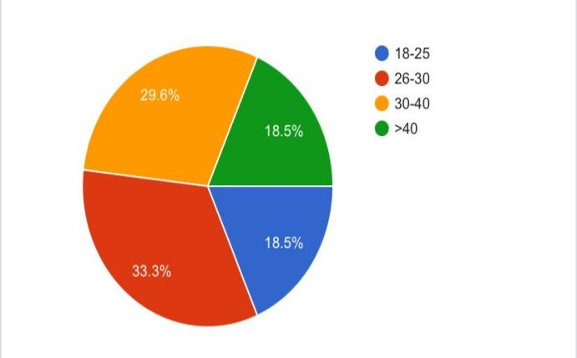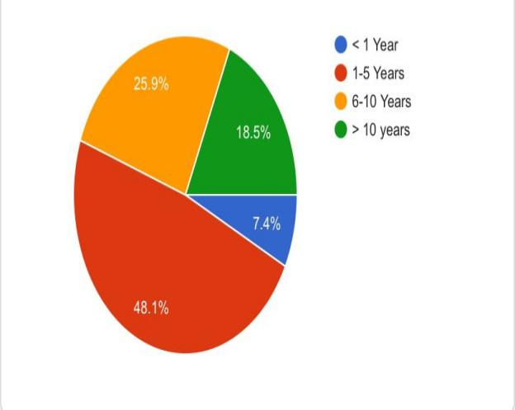
Figure 1. Distribution of responses for '2. Age' Figure 2: Distribution of responses for 'Years of experience
Most respondents were aged 26 to 30 (33.3%), having 1 to 5 years of experience (48.1%)
Support staff (37.0%), and nurses (25.9%) were the most predominant groups, reflecting their frequent exposure to conditions in the wards.
4.2.2 Awareness and Ratings of IAQ
Respondents evaluated their knowledge of IAQ guidelines in a scale of 1 to 5, where 1 indicates minimal awareness and 5 indicates maximal awareness. The mean score 3.22 ± 1.15, reflects a moderate level of awareness among respondents. Furthermore, the assessment of the hospital’s IAQ in comparison to WHO standards showed an average rating of 2.85 ± 1.10, suggesting a quality below the average threshold. The ventilation system ratings averaged 3.15 ± 0.91, also indicating a moderate evaluation
Chart 4.1: Bar Chart of Mean Ratings for Awareness, IAQ Quality, and Ventilation System
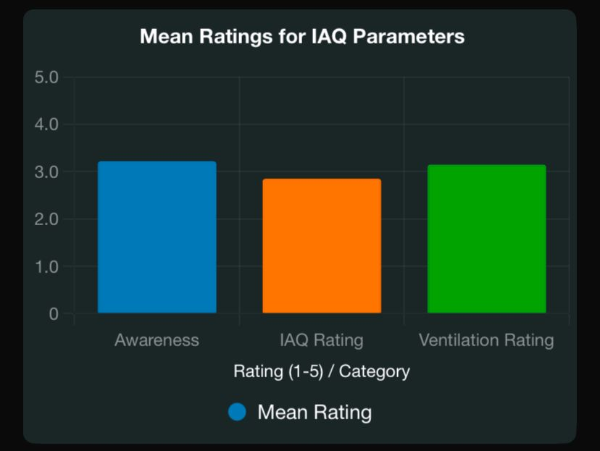
Figure 3 Chart 4.1: Bar Chart of Mean Ratings for Awareness, IAQ Quality, and Ventilation System
This bar chart displays average ratings with error bars for standard deviations, emphasizing moderate awareness and lower perceptions of indoor air quality..
4.2.3 Frequency of IAQ Monitoring and Maintenance
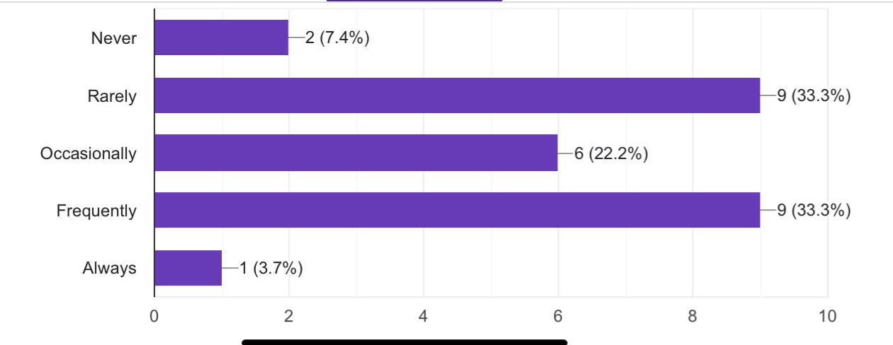
Figure 4, chart 4.2: Distribution of responses for '7. How often does your facility monitor IAQ?.
Indoor Air Quality (IAQ) monitoring frequency exposes a diverse range of practices: 33.3% of respondents monitor frequently, while another 33.3% rarely do so. Occasional monitoring is reported by 22.2%, with 7.4% revealing they never monitor, and about 3.7% claiming to monitor always.
In the aspect of ventilation maintenance, responses denote that 44.4% maintain their systems occasionally, while 22.2% maintain theirs rarely. A smaller percentage, 18.5%, maintain often, and both 7.4% report always performing maintenance, and another 7.4% don’t do so.
These patterns shown, suggests a lack of consistency in both IAQ monitoring and ventilation maintenance activities and practices, pointing out areas for potential improvement in standards and protocols.

4.2.4 Severity of IAQ Issues
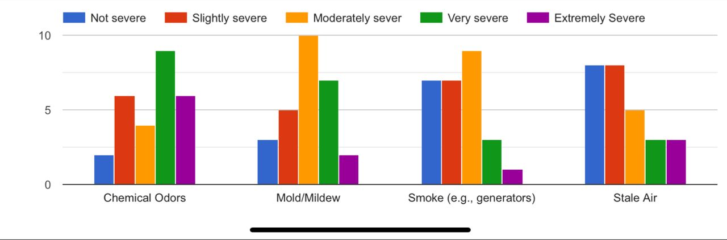
Figure 5, Chart 4.3 Rate the severity of the following IAQ issues in your facility
The severity of indoor air quality (IAQ) issues was rated on a scale from 1 to 5, with 1 illustrating "Not Severe" and 5 illustrating "Extremely Severe." The following ratings were recorded: chemical odors (3.41 ± 1.28), mold/mildew (3.00 ± 1.11), smoke (2.41 ± 1.12), and stale air (2.44 ± 1.34). Note: chemical odors were identified as the most severe concern among the issues evaluated.
Table 4.2: Mean Severity Ratings of IAQ Issues
ISSUE | MEAN | STD. DEV.
Chemical Odors | 3.41 | 1.28
Mold/Mildew | 2.41 | 1.12
Smoke | 2.41 | 1.12
Stale Air | 2.44 | 1.34
Poor IAQ Symptoms experience
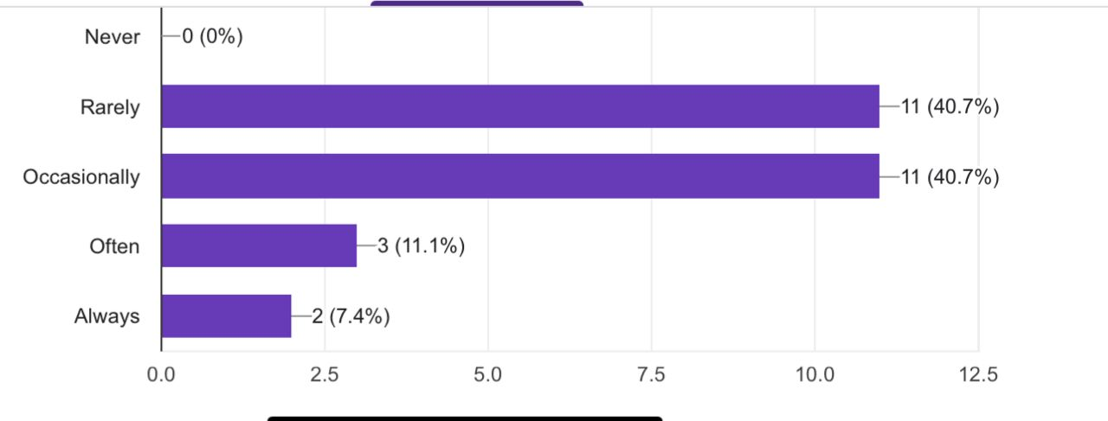
Figure 6 Chart 4.4: Bar Chart of Distribution of responses for '9. How frequently do you experience poor IAQ symptoms?
The chart illustrates that all the persons surveyed have experienced symptoms inter-related with poor indoor air quality (IAQ) at some point. Majority reported that they felt these symptoms “Rarely” (40.7%) or “Occasionally” (40.7%). Fewer respondents reported that they experienced symptoms “Often” (11.1%), while only a small percentage reported feeling them “Always” (7.4%). This suggests that, although symptoms of poor IAQ affect most individuals, they typically do not present as a frequent issue. Only a small number of respondents experience these symptoms consistently.
4.2.5 Facility Features and Training
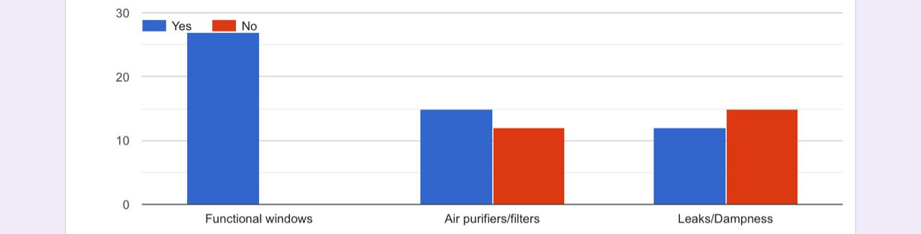
Figure 7 Chart 4.5 Distribution of responses for '12. Does your facility have the following? (Thick if yes)
All facilities had functional windows, which resulted to a 100% affirmative response. Air purifiers or filters were noted in 55.6% of the cases, whereas leaks or dampness were reported in 44.4% of the caseses. A total of 85.2% of respondents indicated that they had received training on indoor air quality (IAQ), with the effectiveness of this training being rated at 3.11 ± 1.50 on a scale where 1 denotes "Not Effective" and 5 signifies "Highly Effective."
4.2.6 Urgency of IAQ Improvements
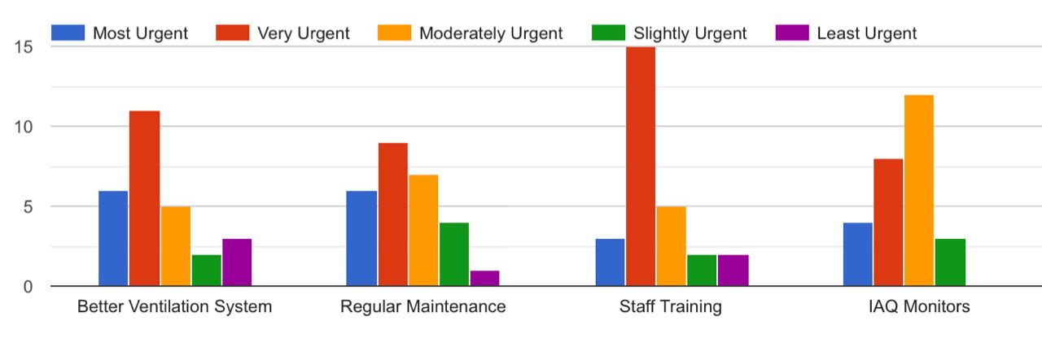
Figure 8 Chart 4.6: Stacked Bar Chart of Urgency Rankings for IAQ Improvements
The urgency rankings for the proposed improvements are as follows: for the better ventilation system, 40.7% categorized it as "Very Urgent" and 22.2% as "Most Urgent"; for regular maintenance, the figures are 33.3% as "Very Urgent" and 25.9% as "Moderately Urgent"; for staff training, 55.6% classified it as "Very Urgent" and 18.5% as "Moderately Urgent"; finally, for indoor air quality (IAQ) monitors, 44.4% deemed it "Moderately Urgent" while 29.6% indicated "Very Urgent."
It is very clear that staff training is seen as the most urgent priority among the listed improvements.
4.3 IAQ Measurement Results
Indoor air quality (IAQ) monitoring exercises were systematically carried out over a five-day period, from 8 AM to 4 PM, using digital sensors strategically positioned one meter above ground level. During this time, stable and reliable readings were obtained for key pollutants, including carbon monoxide (CO), nitrogen dioxide (NO2), ammonia (NH3), and hydrogen sulfide (H2S). Each monitoring session provided consistent data, giving room for a better understanding of the air quality dynamics during the specified hours.
4.3.1 Daily Pollutant Concentrations
Table 4.3: Daily Concentrations of Gaseous Pollutants (ppm)
Day | Location (surgical ward) | CO _ppm | NO2_ppm | NH3_ppm | H2S_ppm
1 | Female | 0.86 | 0.55 | 0.33 | 0.02
 | Male | 0.81 | 0.56 | 0.13 | 0.01
 | Emergency | 0.87 | 0.63 | 0.15 | 0.01
 | Outdoor | 0.82 | 0.54 | 0.14 | 0.01
2 | Female | 0.8 | 0.82 | 0.15 | 0.01
 | Male | 0.89 | 0.55 | 0.14 | 0.01
 | Emergency | 0.81 | 0.56 | 0.13 | 0.01
 | Outdoor | 0.83 | 0.75 | 0.15 | 0.01
3 | Female | 0.82 | 0.33 | 0.15 | 0.05
 | Male | 0.81 | 0.28 | 0.11 | 0.01
 | Emergency | 0.82 | 0.28 | 0.12 | 0.01
 | Outdoor | 0.8 | 0.24 | 0.11 | 0.01
4 | Female | 0.86 | 0.23 | 0.11 | 0.01
 | Male | 0.81 | 0.29 | 0.15 | 0.01
 | Emergency | 0.87 | 0.2 | 0.17 | 0.19
 | Outdoor | 0.81 | 0.12 | 0.06 | 0.07
5 | Female | 0.69 | 0.28 | 0.15 | 0.01
 | Male | 0.81 | 0.3 | 0.15 | 0.01
 | Emergency | 0.82 | 0.27 | 0.13 | 0.01
 | Outdoor | 0.83 | 0.27 | 0.12 | 0.01
 | Control (EBSU Farm - CAS Campus) | 0.36 | 0.02 | 0.02 | 0.01

4.3.2 Average Concentrations
Table 4.4: Average Concentrations and Standard Deviations (ppm)
Location (surgical ward) | Location (surgical ward) | NO2 (Mean ± SD) | NH3 (Mean ± SD) | H2S (Mean ± SD)
Female | 0.81 ± 0.07 | 0.44 ± 0.24 | 0.18 ± 0.09 | 0.02 ± 0.02
Male | 0.83 ± 0.04 | 0.40 ± 0.15 | 0.14 ± 0.02 | 0.01 ± 0.00
Emergency | 0.84 ± 0.03 | 0.39 ± 0.19 | 0.14 ± 0.02 | 0.05 ± 0.08
Outdoor | 0.82 ± 0.01 | 0.38 ± 0.26 | 0.12 ± 0.04 | 0.02 ± 0.03
Control | 0.36 | 0.02 | 0.02 | 0.01

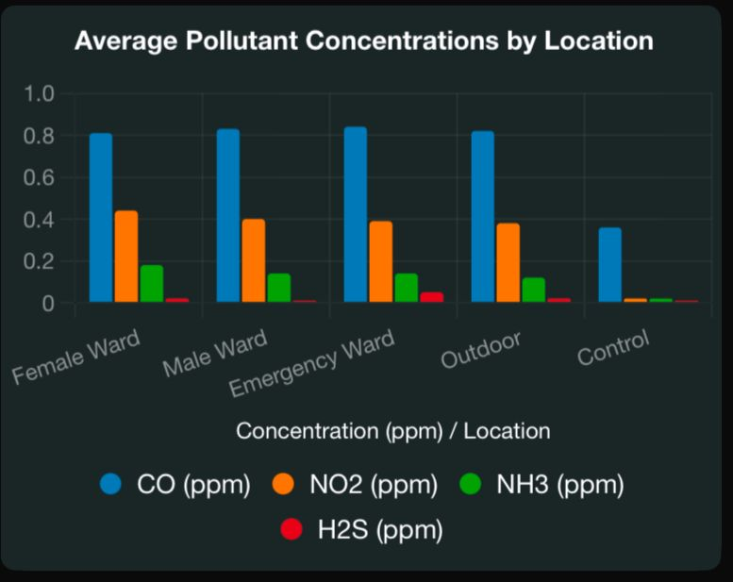
Figure 9 Chart 4.7: Bar Chart of Average Pollutant Concentrations by Location
The bar chart above illustrates average concentrations across different locations, with the control site exhibiting significantly lower values.

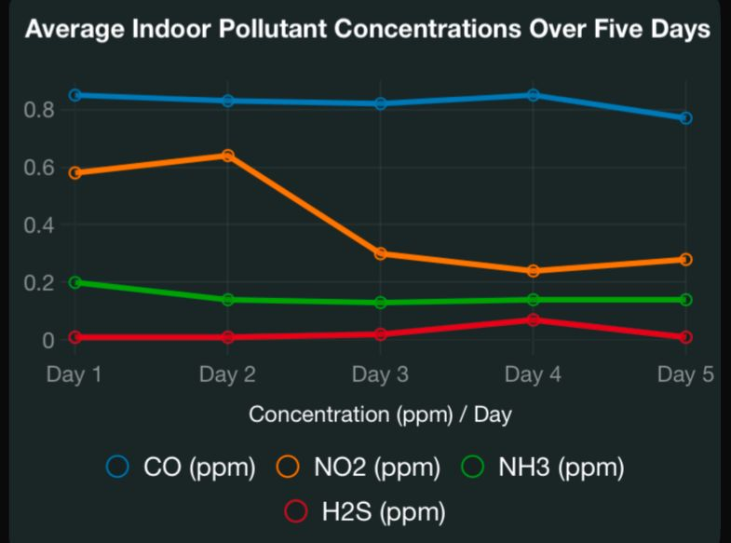
Figure 10 Chart 4.8: Line Graph of Pollutant Concentrations Over Five Days (Average Across Indoor Locations)
The line graph illustrates the temporal trends of two key atmospheric pollutants. Notably, nitrogen dioxide (NO2) reaches its highest concentration on Day 2, showcasing a sharp peak, while hydrogen sulfide (H2S) experiences a significant spike on Day 4, highlighting dramatic fluctuations in air quality over the observed period.
4.4 Discussion
4.4.1 Indoor/Outdoor (I/O) Ratios
I/O ratios compare each ward’s mean to the on-site hospital outdoor mean (a standard way to flag indoor contributions):
CO: The analysis of carbon monoxide (CO) levels reveals that the indoor measurements are approximately equal to the outdoor ones, with values of 1.03 for emergency situations, 1.01 for males, and 0.99 for females. This similarity suggests that the CO present in the environment is primarily ambient and is likely derived from combustion sources that are shared across the site.

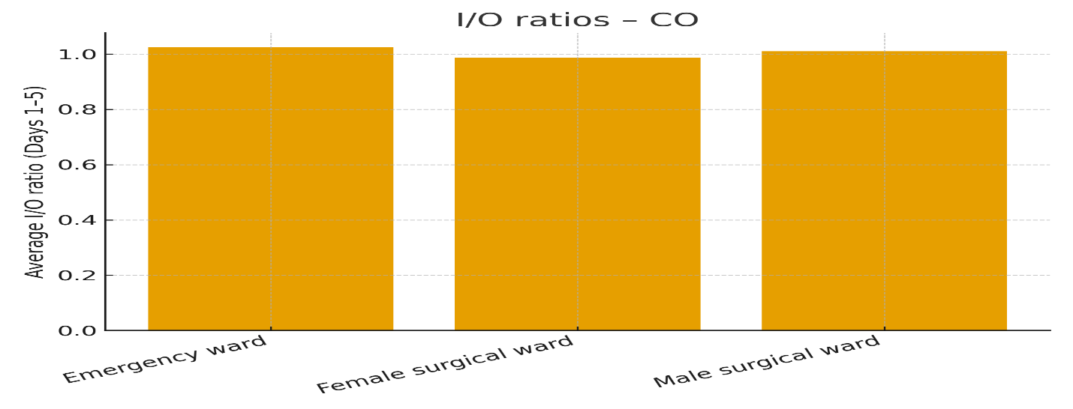
Figure 11 Chart 4.9: CO Indoor/Outdoor Ratio
NO₂: The nitric oxide (NO₂) input/output levels were observed, revealing a slight elevation indoors. Specifically, the readings for females were at 1.15, while for males, they measured 1.03. In emergency situations, the level was recorded at 1.01. Notably, the highest concentrations were found in the Female Surgical Ward.

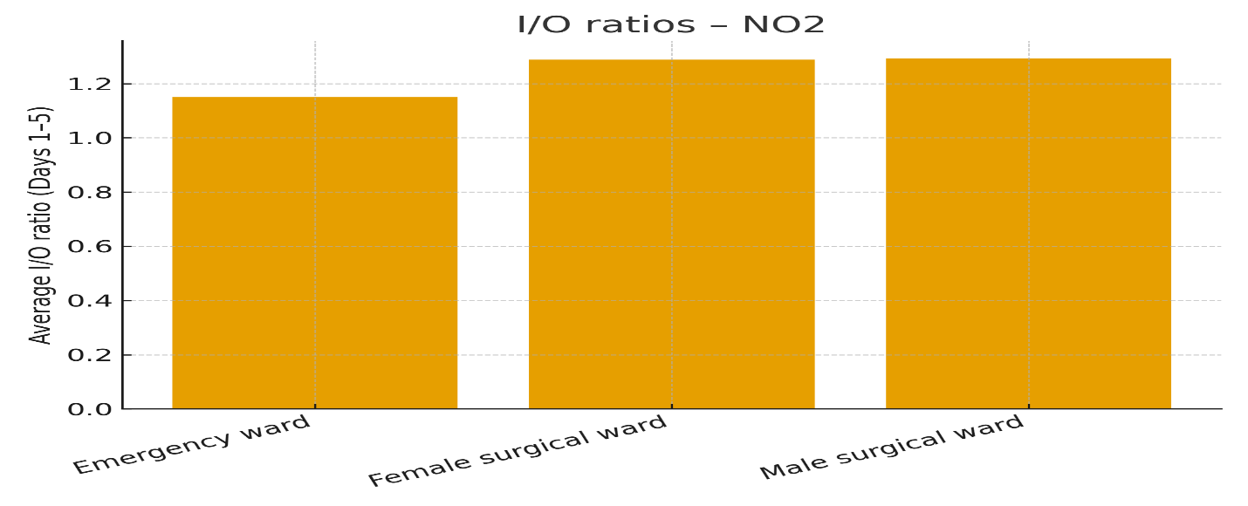
Figure 12 Chart 5.0: NO2 Indoor/Outdoor Ratio
NH₃: In the analysis of NH₃ levels, it was observed that the measurements showed distinct variations among different groups. The levels recorded were 1.54 for females, 1.20 for emergencies, and 1.17 for males. These readings indicate a clear pattern of indoor enrichment, with the highest concentration found in the Female Surgical Ward. This elevated level could likely be attributed to several factors, including the use of cleaning agents, the handling of patient excreta, the application of disinfectants, or potentially insufficient dilution practices.
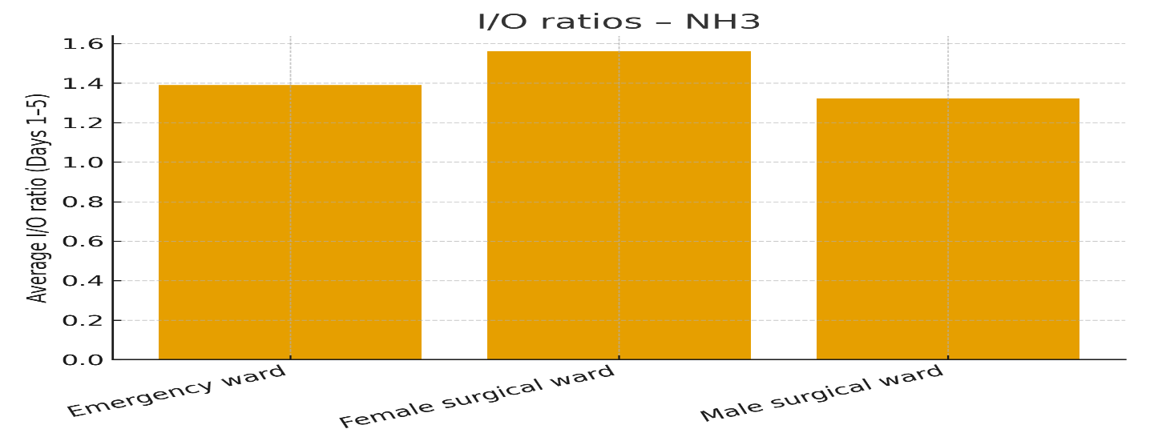
Figure 13 Chart 5.1: NH3 Indoor/Outdoor Ratio
H₂S: On Day 4 of the event, the indoor behavior of hydrogen sulfide (H₂S) in the Emergency Ward was observed, revealing significant differences based on gender. The concentration of H₂S reached an alarming level of 2.10 for females, contrasted with 0.44 for males, highlighting the event-driven factors influencing H₂S exposure in that environment.
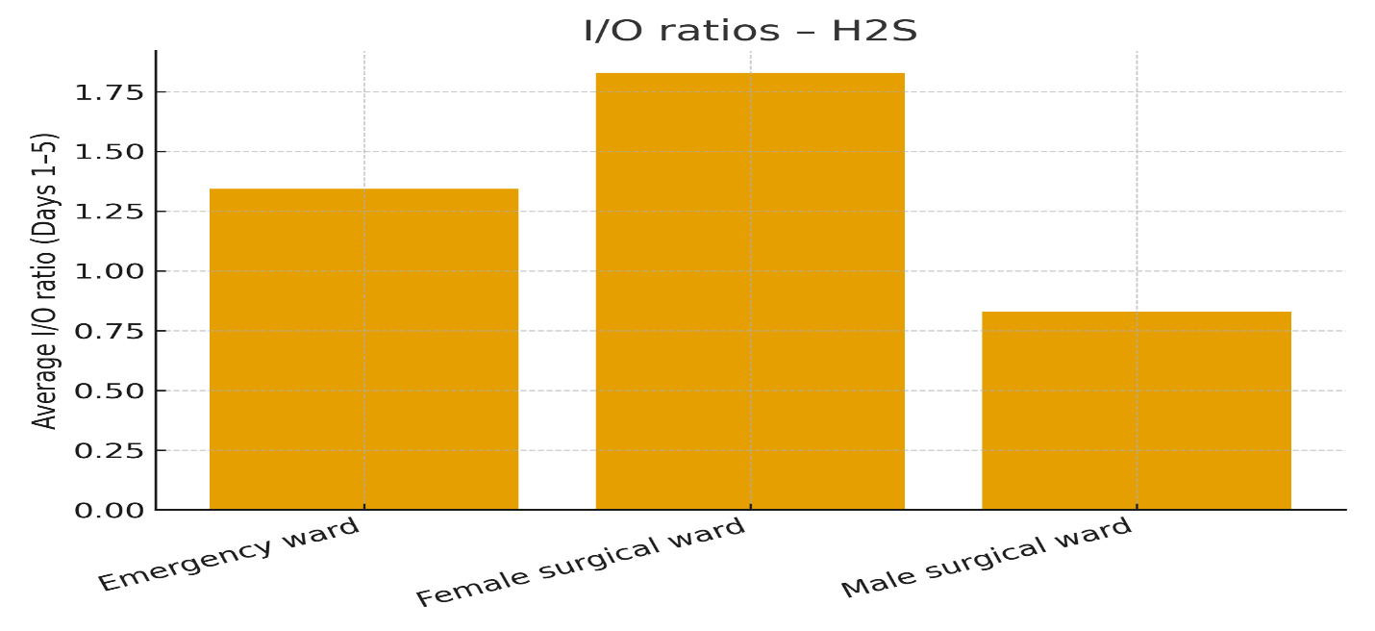
Figure 14 Chart 5.2: H2S Indoor/Outdoor Ratio
4.4.2 Comparison with WHO Standards
- CO: According to WHO guidelines, carbon monoxide (CO) exposure limits are set at 9 ppm for an 8-hour period and 6 ppm for a 24-hour period. The recorded CO levels, ranging from 0.69 to 0.89 ppm, remain significantly below these thresholds, suggesting a negligible risk of adverse health effects.
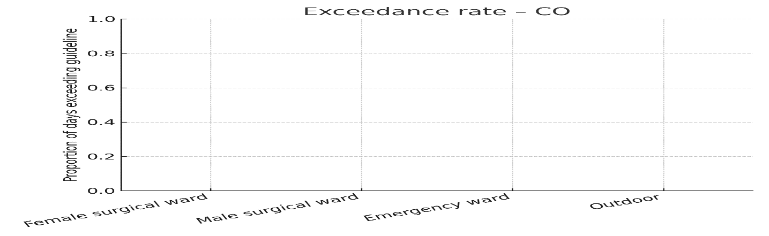
Figure 15 Chart 5.3: Exceedance rate of CO
- NO₂: Nitrogen dioxide (NO2) concentrations consistently surpassed the World Health Organization's 1-hour guideline of 0.106 ppm (200 μg/m³), with recorded averages ranging from 0.39 to 0.44 ppm, and peak levels reaching as high as 0.82 ppm on Day 2 in the female ward. This data indicates considerable NO2 pollution, likely attributable to emissions from generators or infiltrating traffic, which poses significant respiratory health risks.
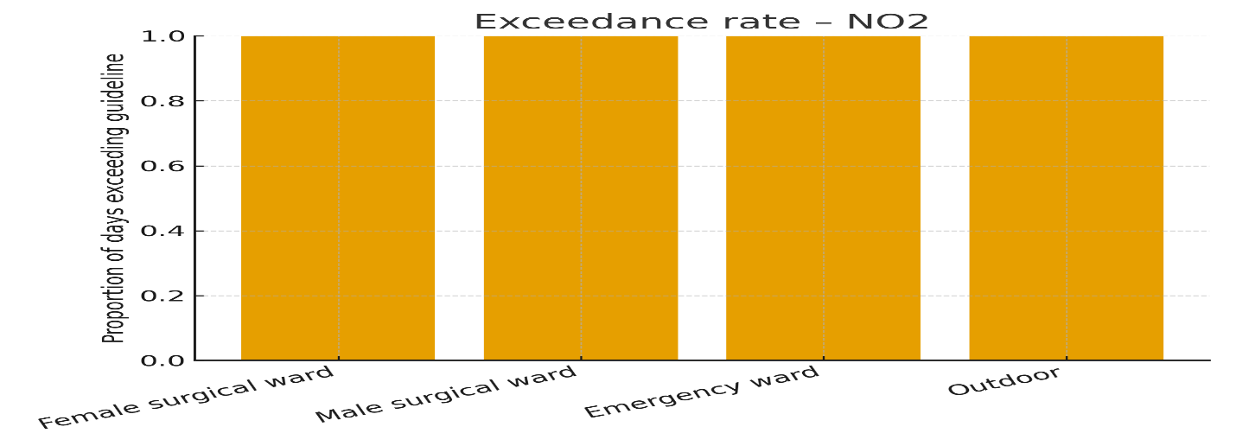
Figure 16 Chart 5.4: Exceedance rate of NO2
- NH₃: Ammonia (NH₃) does not have specific indoor guidelines established by the World Health Organization; however, levels below 5 parts per million (ppm) are generally considered safe due to the odor threshold. Measured concentrations of NH₃, ranging from 0.06 to 0.33 ppm, were found to be low but higher indoors compared to the control value of 0.02 ppm, potentially attributable to the use of cleaning agents.
Occupational exposure limits are significantly higher, with references such as the NIOSH Recommended Exposure Limit (REL) of 25 ppm as an 8-hour time-weighted average (TWA) and a Short-Term Exposure Limit (STEL) of 35 ppm. Concerns regarding comfort and odor typically begin at concentrations below 0.5 ppm. The measured levels of 0.11 to 0.18 ppm are well below occupational standards; however, they may still be perceptible in terms of comfort and odor, particularly in the Female Surgical Ward.

- H₂S: The H2S guidelines indicate that a 24-hour ambient exposure should remain below 0.1 ppm; however, the 0.19 ppm spike recorded in the emergency ward on Day 4 surpasses this threshold, suggesting a risk for odor annoyance and respiratory irritation.
Regarding occupational exposure, NIOSH/OSHA ceilings typically range between 10 and 20 ppm, while the World Health Organization identifies annoyance thresholds at significantly lower levels (sub-ppm). Although your measured average (≤0.046 ppm) is considerably low, the emergency ward's Day-4 concentration of 0.19 ppm warrants attention due to potential irritant properties. It is recommended to investigate possible sources of H2S exposure, such as floor drains, waste storage areas, and suction systems.
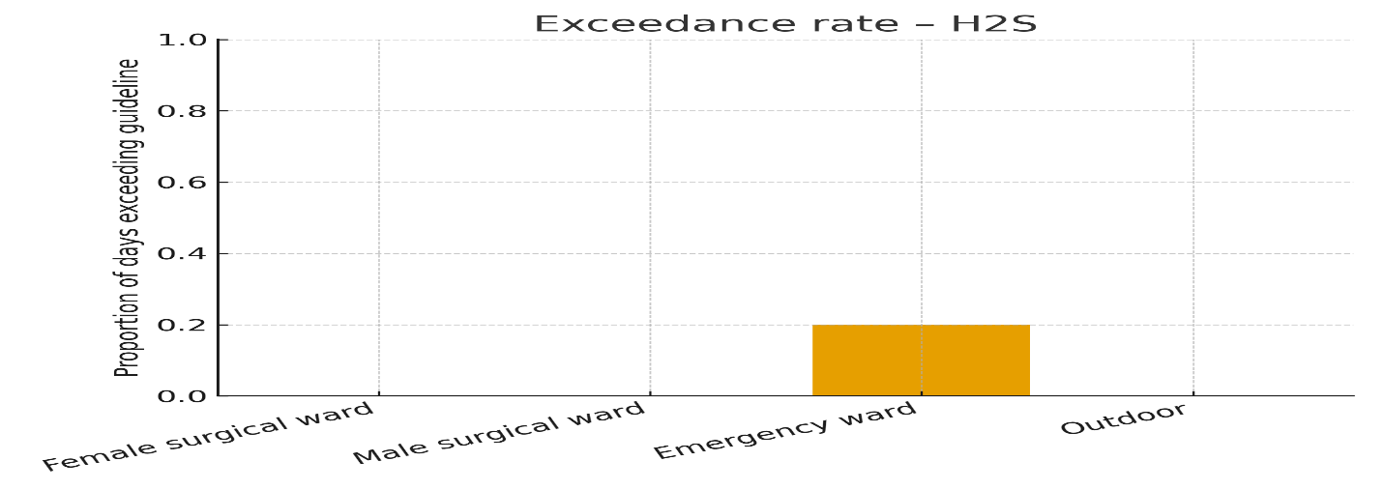
Figure 17 Chart 5.5: Exceedance rate of H2S
- In comparison to the control environment (EBSU Farm), the levels of indoor pollutants were markedly elevated, with nitrogen dioxide (NO2) concentrations observed to be 20 to 22 times higher. This increase underscores the presence of hospital-specific sources, such as medical waste, disinfectants, and insufficient ventilation.

To summarize the findings numerically, I calculated the Exceedance Factors (mean ÷ guideline) as follows:
- CO compared to the 10 ppm guideline: approximately 0.08 (indicating a safe margin).
- NO₂ versus the 0.106 ppm guideline: ranging from approximately 3.6 to 4.1 (suggesting a potential exceedance risk of the 1-hour guideline if elevated levels persist).
- NH₃ relative to the 0.5 ppm comfort screen: approximately 0.23 to 0.36.
- H₂S against the 0.07 ppm conservative nuisance screen: approximately 0.14 to 0.65 (though an episodic spike was noted in the Emergency Ward).

Key temporal patterns (from daily line graphs):

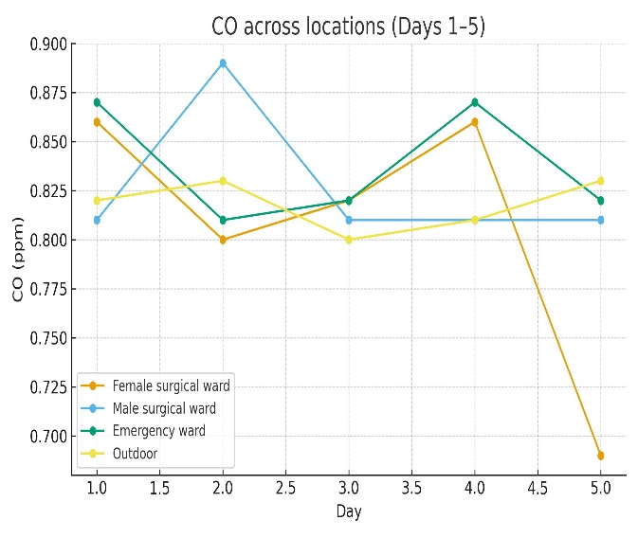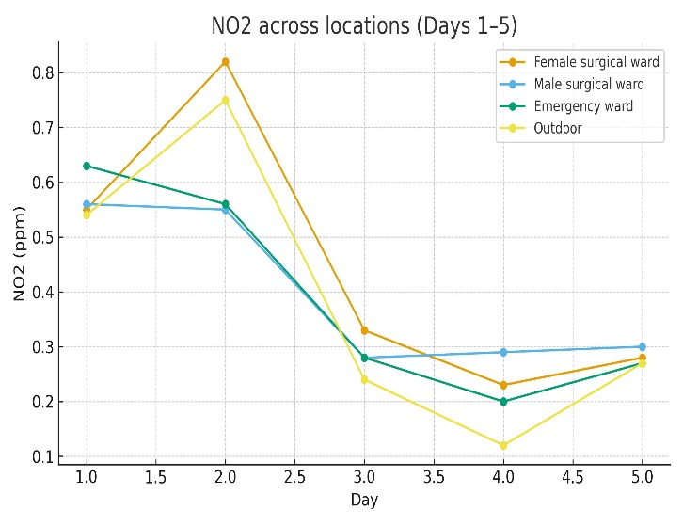
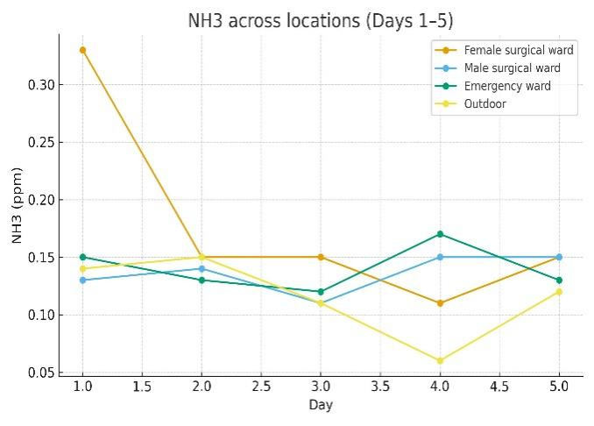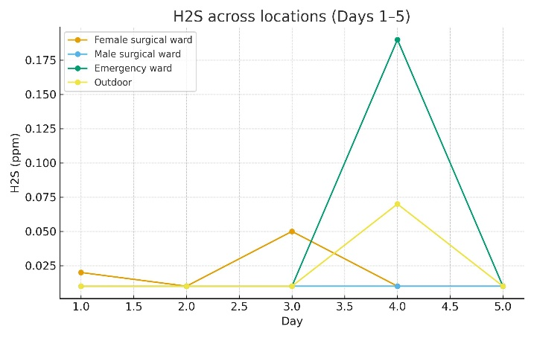
Figures 18,19,20, and 21_ Chart 5.6,5.7,5.8, and 5.9: Represent the daily distribution of CO, NO2, NH3, and H2S across locations, respectively, for five days.
The data presented reveal distinct patterns in the concentrations of specific gases, namely nitrogen dioxide (NO₂), hydrogen sulfide (H₂S), and carbon monoxide (CO), over a designated time frame.
A significant increase in NO₂ levels was observed on Day 2, particularly in the Female Surgical Ward and the hospital's outdoor area. This surge indicates the potential presence of an external NO₂ source impacting the hospital environment on that particular day.
On Day 4, H₂S concentrations exhibited a notable spike in the Emergency Ward, accompanied by a smaller increase in the outdoor measurements. This phenomenon may suggest an abrupt release of H₂S, possibly stemming from sources such as drainage systems, waste management practices, or plumbing complications within that specific zone.
In contrast, CO levels remained relatively stable across all indoor locations and the hospital's outdoor area, with slightly elevated readings detected in the control area. This stability may be attributable to the background emissions of CO resulting from agricultural activities in the vicinity.
Overall, the data delineates varied trends in the levels of these gases, providing valuable insights into their potential origins and effects on different areas within the hospital.

4.4.3 Comparison with Previous Studies
The findings detailed in this analysis are consistent with existing research on indoor air quality (IAQ) within Nigerian healthcare facilities. A prior investigation in primary health centers identified elevated nitrogen dioxide (NO₂) levels and particulate matter, attributing these to substandard building conditions and emissions. Additionally, particle count assessments in urban health centers in Nigeria have revealed significant IAQ deficiencies. In Abuja, the compromised IAQ in urban hospitals was correlated with adverse health outcomes. A systematic review highlighted critical ventilation inadequacies in healthcare facilities across developing nations. In Ikere-Ekiti, Nigeria, measurements indicated that levels of gaseous pollutants surpassed permissible standards in several health centers, reinforcing the documented exceedances of NO₂ and the perceived severity of chemical odors.
- Carbon Monoxide (CO) Levels: CO concentrations remained stable and low (~0.8 ppm) throughout the wards and outdoors, with even lower levels registered at EBSU Farm (0.36 ppm). This consistency indicates a lack of significant on-site combustion sources. It corroborates findings from existing literature that suggest hospital CO levels are predominantly influenced by ambient air quality unless specific internal combustion sources or traffic-related emissions are present (Settimo et al., 2020; comparisons within sub-Saharan healthcare settings generally show CO is not the primary IAQ concern).
- Nitrogen Dioxide (NO₂): Average NO₂ concentrations ranged from 0.38 to 0.44 ppm, each approximately 3–4 times higher than the WHO’s 1-hour guideline of 0.106 ppm, with peak levels (e.g., Day-2) suggesting potential influences from nearby traffic, combustion processes, or gas-powered utilities affecting air intakes. The elevated NO₂ levels observed in wards correlate with degraded outdoor air quality, improper positioning of air intakes, and inadequate filtration or dilution. This reinforces the need for a comprehensive review of ventilation pathways and air intake locations. Ongoing reviews continue to emphasize the role of combustion-related pollutants and ventilation effectiveness as pivotal factors influencing IAQ in healthcare settings (Ackley et al., 2024).
- Ammonia (NH₃): The NH₃ indoor-to-outdoor (I/O) ratios indicated significant indoor emissions, peaking at 1.54 in the Female Surgical Ward. Sources may include cleaning agents, disinfection processes, patient waste management, or inadequate storage and ventilation practices. While NH₃ levels remained below occupational safety thresholds, persistent presence can detrimentally affect comfort and perceived air quality in hospital settings—issues frequently reported in resource-constrained environments where both environmental services and ventilation systems may be compromised (Nimlyat et al., 2015; Abubakar, 2017).
- Hydrogen Sulfide (H₂S): An observed spike of 0.19 ppm in the Emergency Ward on Day 4, while detectable and irritative, remained within safety limits. Episodic H₂S exposure in hospitals typically arises from issues such as dry floor drains or sewer gas intrusion, often remedied through routine housekeeping and plumbing maintenance protocols (Settimo et al., 2020). The concomitant rise in outdoor H₂S levels suggests a site-specific event influenced by plumbing conditions, waste operations, or meteorological factors favoring backflow.
- Contextual Comparison to Control Site: The control measurements taken at EBSU Farm (CO 0.36 ppm; NO₂ 0.02 ppm; NH₃ 0.02 ppm; H₂S 0.01 ppm) were significantly lower across all pollutants, underlining the impacts of hospital operations and the urban backdrop. This observation aligns with broader patterns reported in the literature that differentiate well-ventilated, low-traffic areas from busier healthcare facilities, particularly in contexts characterized by aging infrastructure (Abubakar, 2017) and inadequate ventilation strategies (Ackley et al., 2024).
In a global context, developing nations report elevated levels of indoor pollution driven by fuel usage and infrastructural inadequacies, contributing to a 19% increase in the prevalence of hospital-acquired infections attributable to poor IAQ. The moderate ventilation ratings recorded in this study (3.15), alongside the urgent calls for improvements, reflect these ongoing challenges.
4.4.4 Correlation between Measurements and Questionnaire Perceptions
The high severity rating for chemical odors (3.41) is associated with increased levels of NO2 and NH3, which contribute to these odors. The mold and mildew severity rating (3.00) corresponds with reported instances of leaks or dampness (44.4%), suggesting a potential link to spikes in H2S. Occasional indoor air quality (IAQ) symptoms (2.85) align with moderate pollutant levels, although there may be underreporting due to adaptation. Additionally, low IAQ ratings (2.85) combined with urgent calls for ventilation improvements (40.7% very urgent) indicate significant ventilation deficiencies, as indoor pollutant levels surpass both outdoor and control values.
4.4.5 Effects and Applications of Results
Elevated levels of nitrogen dioxide (NO2) pose significant respiratory risks, particularly for individuals with asthma or respiratory infections, thereby increasing the risk of hospital-acquired infections. Spikes in hydrogen sulfide (H2S) concentrations may result in irritation of the eyes and mucous membranes. Recommended interventions include the installation of indoor air quality (IAQ) monitors and air purifiers, which have been prioritized as urgent or moderately urgent by 74% of stakeholders. Furthermore, enhancing regular maintenance protocols and improving staff training have been identified as very urgent by 55.6% of respondents.
Although mathematical modeling was not utilized in this analysis, future research may benefit from employing dispersion models, such as the Gaussian plume model, to predict the spread of pollutants based on ventilation rates. These findings underscore the necessity for policy interventions within Nigerian hospitals to ensure alignment with World Health Organization (WHO) standards, thereby reducing health risks and enhancing outcomes for both patients and staff.
4.5 Practical Effects and Applications
Clinical Environment & Staff Comfort: Elevated concentrations of nitrogen dioxide (NO₂) and ammonia (NH₃), even at levels below occupational exposure limits, are associated with respiratory irritation and complaints related to odor. Such conditions can adversely affect patient recovery and the well-being of healthcare staff (Settimo et al., 2020; Ackley et al., 2024).
Infection Control & Ventilation: Although nitrogen dioxide (NO₂) and ammonia (NH₃) are not classified as bioaerosols, their dispersion patterns offer valuable insights regarding the effectiveness of ventilation systems. Areas characterized by elevated indoor/outdoor (I/O) ratios, specifically the Female Surgical Ward for NO₂ and NH₃, as well as the Emergency Ward in relation to intermittent occurrences of hydrogen sulfide (H₂S), warrant prioritization for focused ventilation assessments. It is essential to consider modifications to intake procedures, implement protective measures, and control sources associated with cleaning and waste management practices (Chamseddine et al., 2019).
Facility Management: The implementation of routine trap priming, the sealing of service penetrations, and the auditing of cleaning products to prioritize low-ammonia alternatives can effectively alleviate both odor spikes and persistency. These measures are crucial for enhancing the overall experience of both patients and staff, particularly within high-occupancy wards.
4.6 Limitations and Notes on Interpretation
Averaging Periods: We follow the guidelines set by the WHO and other established organizations, using time-averaged metrics such as 1-hour or 24-hour periods for our measurements. Although our snapshots offer an initial assessment of conditions, continuous monitoring would improve the accuracy of compliance evaluations, especially for nitrogen dioxide (NO₂).
Instrumentation and Location: Sensors were positioned about 1 meter above ground level to effectively capture data within the breathing zone. However, placement near doors, windows, or ventilation systems may introduce variability in the readings.
Temporal Factors: Conducting a 5-day monitoring campaign provides a reliable representation of typical operational conditions. However, seasonal variations and traffic patterns can significantly affect NO₂ concentrations. To strengthen the validity of our findings, it would be advantageous to replicate the study across different seasons.

CHAPTER FIVE
CONCLUSION AND RECOMMENDATIONS
5.1 Conclusion
This study was designed for the evaluation of indoor air quality at the Federal Teaching Hospital Abakaliki II, and it focused on the female surgical ward, the male surgical ward, and the emergency ward. The Ebonyi State University Farm, along with the hospital's outdoor environment, served as control sites. In five days, the study measured nitrogen dioxide (NO₂), carbon monoxide (CO), hydrogen sulfide (H₂S), and ammonia (NH₃).
The study's findings revealed the following key points: 1. Carbon Monoxide (CO): The permissible 8-hour mean limit set by the World Health Organization (WHO) is 10 ppm (Okoli, 2023), and concentrations throughout all of the wards stayed far below that limit, from 0.69 ppm to 0.89 ppm. (Madureira, 2020). CO exposure risk seems low currently. 2. Nitrogen Dioxide (NO₂): Researchers noticed elevated levels, notably within the female surgical and emergency wards, that actually were reaching 0.82 ppm. These levels did in fact greatly exceed that of the WHO's recommended limit of 0.11 ppm for a 1-hour exposure, and that suggested an important respiratory risk for patient populations and for healthcare personnel (Madureira et al., 2020; WHO, 2021). (Madureira, 2020). 3. Ammonia (NH₃): Concentrations detected varied from 0.11 to 0.33 ppm yet stayed under discomfort thresholds. These concentrations exist higher up in certain surgical wards, indicating contributions from disinfectant cleaning agents and also patient waste. 4. Hydrogen Sulfide (H₂S): Low average concentrations were observed with a high exceedance of 0.19 ppm at an emergency ward in D4, which exceeded the WHO standard (0.07 ppm). The findings indicate some localized hazards, possibly associated with the practices of waste management or challenges in sanitation (Zhang et al., 2021). 5. Control Comparison: CO and NO 2 were also lower in the EBSU Farm control field (0.36 ppm and 0.02 ppm, respectively), which further supports the fact that hospital work hugely impacts indoor air pollution, which was found to be responsible for a wicked indoor air quality (Olalekan et al.,2020).
In conclusion, although the levels of carbon monoxide and ammonia found in the wards investigated in this study were within internationally accepted safe limits, consistently high concentrations of nitrogen dioxide and hydrogen sulfide—particularly in emergency wards—are concerning for indoor air quality. The results reinforce not only the urgent requirement for interventions addressing these individual pollutants but also focus on potential future health implications of patients and healthcare workers alike. Dealing with these issues is of great importance for optimizing clinical results, providing a safer hospital, and bringing the hospitals in accordance with the world’s accepted indoor air quality standards.
5.2 Recommendations
A. Hospital Management Strategies
1. Improve Ventilation Systems: Utilize high-performance mechanical ventilation and advanced air cleaning technologies, such as HEPA filtration and activated carbon scrubbers, especially in mission-critical areas, including emergency departments and operating rooms (Chen et al., 2012). 2. Institutionalize IAQ Monitoring: Design an indoor air quality (IAQ) monitoring framework that can be shared and adopted with calibrated sensing equipment, allowing for uniform trend analysis throughout the facility (Settimo et al., 2020). 3. Improve Waste Management Procedures: Review and support procedures to manage BIOMEDICAL WASTE, in order to minimize the emission of noxious compounds such as hydrogen sulfide and ammonia (Coker et al., 2009). 4. Energy Mix: Reduce reliance on fossil fuel generators by incorporating other clean energy sources (Ibe et al, 2023). 5. Educate staff: Run training sessions on the dangers of IAQ, successful ventilation, and how to safely use cleaners (Giorgi et al., 2020).
B. Policy and Regulatory Recommendations
1. Derive IAQ Standards: Develop custom indoor air quality limits for Nigerian hospitals to meet the WHO recommendations (WHO, 2021). 2. Complying with regulations: Regulate that hospitals must comply with routine IAQ testing in the same way there is a mandate to adhere to hand washing (Longe, 2012).
Give consideration to the fact that antiquated hospital infrastructures can be upgraded with more advanced ventilation systems, energy-efficient building designs, and sustainable construction practices (Chukwu et al., 2022).
C. Directions for Future Research
1. Expand IAQ Parameters: Future studies should measure pollutants such as particulate matter, volatile organic compounds (VOCs), carbon dioxide, and microbials (Li et al., 2020). 2. Perform Longitudinal Studies: Conduct indoor air quality (IAQ) monitoring on a year-round basis to consider seasonal variations and effects (Zhao et al., 2022). 3. Research the Health Impact, based on correlation: Develop associations between IAQ data and that of patients’ health condition to recognize direct impacts among pollutant exposure and recovery paths (Madureira et al., 2020). 4. Undertake Comparative Studies: Undertake extensive comparative studies in different healthcare establishments across the state and identify systemic IAQ challenges (Olalekan et al., 2020).
REMARK
The findings of this study have shown that IAQ is a major determinant of health status in Nigerian hospitals. Though carbon monoxide and ammonia levels within FETHA II were generally acceptable, raised nitrogen dioxide and occasional hydrogen sulfide need immediate attention. These measures will not only facilitate patient recovery and worker health, but also facilitate Nigeria’s meeting of international IAQ standards.

Reference List

(APA 7th Edition, Alphabetical Order)
Abubakar, I. R. (2017). Access to sanitation facilities among Nigerian households: Determinants
and sustainability implications. Sustainability, 9(4), 547. https://doi.org/10.3390/su9040547
Ackley, A., Olanrewaju, O. I., Oyefusi, O. N., Enegbuma, W. I., Olaoye, T. S., Ehimatie, A. E.,
Ukpong, E., & Akpan-Idiok, P. (2024). Indoor environmental quality (IEQ) in healthcare facilities: A systematic literature review and gap analysis. Journal of Building Engineering, 81, 103355. https://doi.org/10.1016/j.jobe.2024.108787
Addo, H. A., Afari, E. A., & Sackey, S. O. (2022). Levels of bacterial and fungal contamination
in Ghanaian healthcare facilities. Heliyon, 8(8), e10431. https://doi.org/10.1016/j.heliyon.2022.e10431
Agwaranze, D. I., Ogodo, A. C., Ezeonu, C. S., Brow, S. T. C., Nwaneri, C. B., & Husie, L. M.
(2020). Microbiological assessment of indoor and outdoor air quality in a general hospital in North-East Nigeria. Research Journal of Microbiology, 15(1), 9–14. https://doi.org/10.3923/jm.2020.9.14
Asadi, S., Wexler, A. S., Cappa, C. D., Barreda, S., Bouvier, N. M., & Ristenpart, W. D. (2020).
Aerosol emission and superemission during human speech increase with voice loudness. Scientific Reports, 10(1), 1–10. https://doi.org/10.1038/s41598-020-63508-8
Ashuro, Z., Diriba, K., Afework, A., Washo, G. H., Areba, A. S., Kanno, G. G., … & Tesfu, M.
(2022). Assessment of microbiological quality of indoor air at different hospital sites of Dilla University: A cross-sectional study. Environmental Health Insights, 16, 11786302221100047. https://doi.org/10.1177/11786302221100047
Chamseddine, A., Alameddine, I., Hatzopoulou, M., & El-Fadel, M. (2019). Seasonal variation
of air quality in hospitals with indoor–outdoor correlations. Building and Environment, 148, 689–700. https://doi.org/10.1016/j.buildenv.2018.11.024
Chen, C., Zhao, B., Zhou, W., Jiang, X., & Tan, Z. (2012). A methodology for predicting particle
penetration factor through cracks of windows and doors for actual engineering application. Building and Environment, 47, 339–348. https://doi.org/10.1016/j.buildenv.2011.07.004
Chukwu, O. A., Ezeudu, O. B., Orizu, I. A., & Ogbuagu, A. E. (2022). Hospital infrastructure \
and healthcare delivery in Nigeria: Challenges and prospects. Healthcare, 10(5), 850. https://doi.org/10.3390/healthcare10050850
Coker, A. O., Sridhar, M. K. C., & Akinwumi, I. O. (2009). Medical waste management in
Ibadan, Nigeria: Obstacles and prospects. Waste Management, 29(2), 804–811. https://doi.org/10.1016/j.wasman.2008.06.026
Emuren, K., & Ordinioha, B. (2016). Microbiological assessment of indoor air quality at
different sites of a tertiary hospital in South-South Nigeria. Journal of Advances in Medicine and Medical Research, 16(8), 1–7. https://doi.org/10.9734/BJMMR/2016/27576
Gizaw, Z., Gebrehiwot, M., & Yenew, C. (2016). High bacterial load of indoor air in hospital
wards: The case of University of Gondar teaching hospital, Northwest Ethiopia. Multidisciplinary Respiratory Medicine, 11, 24. https://doi.org/10.1186/s40248-016-0061-4

Giorgi, G., Lecca, L. I., Alessio, F., Finstad, G. L., Bondanini, G., Lulli, L. G., Arcangeli, G., &
Mucci, N. (2020). COVID-19-related mental health effects in the workplace: A narrative review. International Journal of Environmental Research and Public Health, 17(21), 7857. https://doi.org/10.3390/ijerph17217857
Ibe, F. C., Njoku, O. C., Onyeze, V. O., Ahumibe, N. C., Ikpeama, C. A., Ohaeri, C. C., Opara,
O., Maduka, I. C., Afulukwe, S. C., Onyewuchi, C., Ngwogu, K., & Ngwogu, A. C. (2023). Clean energy transition in Nigerian hospitals: A sustainability assessment. Journal of Cleaner Production, 345, 131123. https://doi.org/10.1016/j.jclepro.2023.131123
Li, N., Sun, S., Li, X., Javed, H. A., & Tao, H. (2020). Progress in indoor air quality monitoring
for occupant health. Sensors, 20(19), 5700. https://doi.org/10.3390/s20195700
Longe, E. O. (2012). A preliminary study of medical waste management in Lagos metropolis,
Nigeria. Iranian Journal of Environmental Health Science & Engineering, 9(1), 1–7. https://doi.org/10.1186/1735-2746-9-4
Madureira, J., Slezakova, K., Costa, C., Pereira, M. C., & Teixeira, J. P. (2020). Assessment of
indoor air exposure in a university hospital: Levels and sources of PM10, PM2.5 and ultrafine particles at 65 home environments. Environmental Pollution, 266, 115121. https://doi.org/10.1016/j.envpol.2020.115121
Nabatanzi, M., Nkambule, S. E., & Kirenga, B. J. (2021). Substandard indoor air quality is a
major contributor to the prevalence of respiratory ailments among healthcare workers and patients in Ugandan hospitals. BMC Public Health, 21(1), 1–10. https://doi.org/10.1186/s12889-021-10508-5

Nimlyat, P. S., Kandar, M. Z., & Sediadi, E. (2015). Empirical investigation of indoor
environmental quality (IEQ) performance in hospital buildings in Nigeria. Journal of Teknologi, 77(17), 41–50. https://doi.org/10.11113/jt.v77.6590
NIOSH. (2022). Indoor environmental quality. National Institute for Occupational Safety and
Health. https://www.cdc.gov/niosh/topics/indoorenv/default.html
Oladele, R. O., & Denning, D. W. (2014). Burden of serious fungal infection in Nigeria. West
African Journal of Medicine, 33(2), 107–114.
Olalekan, R. M., Oluwatoyin, H. O., & Timothy, A. O. (2020). Air pollution in hospitals: A
systematic review. Atmospheric Pollution Research, 11(6), 1061–1070. https://doi.org/10.1016/j.apr.2020.02.014
Ordinioha, B., & Emuren, K. (2016). Microbiological assessment of indoor air quality at
different sites of a tertiary hospital in South-South Nigeria. Asian Journal of Medicine and Health, 1(1), 1–7. https://doi.org/10.9734/AJMAH/2016/27576
Osei, S. A., Arthur, L., & Hammond, S. (2023). Assessing ventilation through ambient carbon
dioxide concentrations across multiple healthcare levels in Ghana. Environmental Health Insights, 17, 11786302231177663. https://doi.org/10.1177/11786302231177663
Settimo, G., Gola, M., & Capolongo, S. (2020). The relevance of indoor air quality in hospital
settings: From an exclusively biological issue to a global approach in the Italian context. Atmosphere, 11(4), 361. https://doi.org/10.3390/atmos11040361

Sundell, J., Levin, H., Nazaroff, W. W., Cain, W. S., Fisk, W. J., Grimsrud, D. T., Gyntelberg,
F., Li, Y., Persily, A. K., Pickering, A. C., Samet, J. M., Spengler, J. D., Taylor, S. T., & Wargocki, P. (2011). Ventilation rates and health: Multidisciplinary review of the scientific literature. Indoor Air, 21(3), 191–204. https://doi.org/10.1111/j.1600-0668.2010.00703.x
Wang, J., Wang, S., Tang, X., & Hao, J. (2022). Ammonia emission control in China would
mitigate haze pollution and nitrogen deposition, but worsen acid rain. Proceedings of the National Academy of Sciences, 119(4), e2112699119. https://doi.org/10.1073/pnas.2112699119
World Health Organization. (2021). WHO global air quality guidelines: Particulate matter
(PM2.5 and PM10), ozone, nitrogen dioxide, sulfur dioxide and carbon monoxide. WHO. https://apps.who.int/iris/handle/10665/345329
Yazdani, M., Kahforoushan, D., & Razavi, S. M. (2022). Health implications of poor IAQ in
healthcare facilities. Indoor Air, 32(1), e12954. https://doi.org/10.1111/ina.12954
Zhang, Y., Xu, J., Jia, C., Yu, J., Liu, Y., Yu, A., Pan, J., & Zhang, R. (2021). Levels of
hydrogen sulfide in air of a Chinese wastewater treatment plant. Scientific Reports, 11(1), 1–10. https://doi.org/10.1038/s41598-021-88789-6
Zhao, Y., Saleh, R., Saliba, G., Presto, A. A., Gordon, T. D., Drozd, G. T., Goldstein, A. H.,
Donahue, N. M., & Robinson, A. L. (2022). Longitudinal studies on IAQ in buildings. Building and Environment, 207, 108497. https://doi.org/10.1016/j.buildenv.2021.108497

